

TEF Thematic Report
Wellbeing & Burnout

December 2025

Table of Contents​
​
Executive Summary 3
Background 4
Introduction 4
Methodology 5
Analysis and Discussion 6
Attrition and intention to leave speciality 6
Working patterns, rotas and working conditions 8
On call frequency 9
Nights and weekends 10
Basic facilities 11
Rota provision 11
Fulfilling training requirements 12
Exception reporting 14
Support and workplace culture 14
Consultant support 14
Educational supervision 15
Support after adverse events 15
Workplace behaviours 15
Regional Workplace Behaviour Champions 16
Wellbeing and work-related sickness 17
Burnout 18
Prevalence of Burnout 18
Burnout category by training year 20
Burnout and associated work-related factors 21
Sickness Absence 21
Consideration of Leaving the Specialty 21
Sense of Belonging and Feeling Valued 22
Recognition of Positive Behaviours 23
Sexual harassment/ inappropriate sexual behaviours 23
Undermining Behaviour 24
Perceptions of Leadership 24
Workload and Learning Needs 25
Rota Gaps 25
Conclusion 26
Limitations 26
Recommendations 26
References 28
Appendix A 28
Placement Recommendation 23.1.2 28
Enjoyment of Placement 29
Appendix B 30
Appendix C 30

​
​
​
​
​
​
​
​
​
​
​
​
​
​
​
Wellbeing and Burnout
Authors: Dr Rosie Tomlins, ST7, West of Scotland NHS Education for Scotland; Dr Nazish Zulfiqar, ST3, HEE Wessex; Hannah Manwell, Workforce Co-ordinator, RCOG.

Executive Summary
This report aims to provide a detailed snapshot of the wellbeing status and burnout risk amongst the current UK O&G trainee workforce. All doctors need to be provided with an adequately resourced, supportive work environment so that they can deliver the highest levels of care.
It is important that rota design considers rest periods, as fatigue can negatively impact both the individual doctor as well as patient safety. Concerningly, 23% of trainees never or rarely feel adequately rested returning to daytime duties after working consecutive night shifts, and the majority of respondents (58.2%) said that they always (5.7%), often (16.6%) or sometimes (35.9%) feel too tired to travel home safely.
In addition to meeting the service needs, rotas must also consider the workforce by addressing work intensity, leave entitlements, training and professional development as well as being cognisant of work-life balance. Working less than full time (LTFT) is becoming increasingly popular, with 40% of the current O&G trainee workforce working at 80% or less.
Trainees reported a lack of time to fulfil training requirements within working hours, with almost half (48.5%) of trainees reporting coming into work on off days or zero days to complete these. 47% of respondents disclosed that they do not have non-clinical sessions built into their working week, and of those that do, a significant proportion cited losing these sessions to cover service provision (sometimes (31.8%), often (29%) or always (11.2%)). In addition, exception reports are not consistently submitted and only 40% feel supported in this process. Accurate tracking of working hours is important to support monitoring of understaffing and to bring about improvements to rota design.
Presently, 20% of trainees are frequently considering (daily/weekly/monthly) to leave the specialty. The most common reasons for intention to leave were lack of work-life balance (46.6%), long working hours (35.8%), intense workload (35.6%), stress (30.5%) and shift working (28.6%). 23.4% of respondents recognised that rota gaps were a contributing factor in their consideration to leave, and some individuals cited a lack of support.
Overall, the feedback regarding educational supervision was positive. However, there are improvements that can be made regarding support after adverse events, consistency of consultant supervision and improving workplace behaviours. It is crucial that these areas are addressed as they can impact on clinical performance, as well as contributing to staff sickness leave.
For the first time, the 2025 TEF survey implemented the Copenhagen Burnout Inventory (CBI) tool to identify trainees’ risk of burnout (high, moderate and low risk), using the seven work-related questions. As such, this report provides a snapshot of the risk of burnout within the O&G trainee workforce. Overall, high burnout risk was observed in 15% of trainees, 47% were at a moderate risk, and the remaining 39% were identified as being at a low risk of burnout. A high risk of burnout was documented in the early–mid specialty training (ST) years, 15.7% at ST1, peaking at 20.3% at ST3. It declined in senior training levels to 10.4% at ST6 and 11.3% at ST7, where low burnout predominated (46.2% at ST6; 49.5% at ST7). The post-CCT group showed that 33.3% were at a high risk of burnout, but this estimate should be interpreted cautiously due to the small sample size (n=6).
The TEF survey found that burnout is a powerful indicator of retention risk, as trainees categorised as highly burnt-out were more than thirty times more likely to contemplate leaving the specialty than their lower-burnout counterparts. It is crucial that all doctors are supported to reduce their risk of burnout, not just those in the high-risk category.
To illustrate the significance of the impact of all absences on the service, the total estimated number of workdays lost for work related physical or mental health issues is approximately 1,467 over a six-month period. Many trainees felt that their working pattern may have contributed to their days of sickness or health concerns, with 19% agreeing and 41% agreeing in part. Other factors felt to have contributed to time off included workplace environment, colleagues, team dynamics and personal circumstances.
To be able to provide safe and compassionate patient care, O&G doctors need a work environment in which they feel physically and psychologically safe. This is also linked to improved staff retention and staff satisfaction, more effective team working and a reduction in the symptoms of burnout.

Background
This report relates to the Training Evaluation Form (TEF) survey which is conducted annually by the Royal College of Obstetricians and Gynaecologists (RCOG) to assess the quality of medical education and training across the UK. TEF 2025 was launched on 5 February 2025 and closed on 18 March 2025.
The RCOG uses the results of the TEF survey to monitor and enhance the educational experience for doctors in training. Participation in TEF is mandatory and is a requirement of the training matrix of progression. Responses to the survey are treated confidentially and reported anonymously, allowing trainees to provide honest feedback about their training experience.

Introduction
Obstetrics and gynaecology (O&G) is a highly demanding speciality. The General Medical Council (GMC) National Training Survey 2025 identified that almost one quarter (23%) of the O&G trainee workforce are at high risk of burnout, second only to Emergency Medicine¹.
Although studies have identified that trainees are at highest risk of burnout², 26% of the entire O&G workforce⁵ and 12.6% of O&G trainers¹ have also been identified as being at a high risk. Therefore, it is likely that all O&G doctors are at risk of experiencing burnout at some point during their careers³.
The O&G workforce is facing ever evolving challenges. Nationally, birth rates are declining but rising obesity rates are making operating technically more challenging, and an ageing population is contributing to more complex clinical decision making and management. More than ever, we are faced with higher patient expectations and public scrutiny of our services.
Additionally, although the RCOG Workforce Report 2022 identified that the attrition rates of trainees within England have declined from 12% in 2013 to 3% in 2019⁴, there remains a high rate of attrition nationwide after doctors receive the Certificate of Completion of Training (CCT); 16% of new consultants leave our speciality within five years of entering the Specialist Register⁵. This leads to increased workload and pressure on an already stretched workforce. It is therefore vital that we examine our trainees’ wellbeing to prevent burnout and protect our current and future workforce, to ensure they can deliver the highest levels of compassionate care to women and girls.
For the first time, the 2025 TEF survey implemented the Copenhagen Burnout Inventory (CBI) tool to identify trainees’ risk of burnout (high, moderate and low risk), using the seven work-related questions. As such, this report provides a snapshot of the risk of burnout within the O&G trainee workforce across the UK.
Burnout is a complex occupational condition, defined as a “state of prolonged physical and psychological exhaustion, which is perceived as related to the individual’s work”⁶. It can be triggered by factors both within and outside of the workplace. Trainees may be affected by burnout at different times throughout the course of their training, with each ST level bringing different challenges and demands as well as varying experiences within different units.
As was cited by the GMC Duties of a Doctor, we should all be working within a supportive work environment⁷. Factors contributing towards cultivating this environment include meeting physical, psychological and self-actualisation needs⁴. As such, this report will also analyse working patterns, working conditions, and workplace culture to highlight areas of excellence and identify opportunities for improvement.

Methodology
Each of the questions identified in the Training Evaluation Form (TEF) survey was descriptively analysed and, where necessary, grouped according to training year, region, and working pattern (full-time or less-than-full-time).
When the number of respondents in a group is <3, relevant results and overall totals have been suppressed to protect the anonymity of respondents.
Burnout was measured by the Copenhagen Burnout Inventory (CBI), a tool for burnout measurement, using the seven work-related questions. Responses were classified as high, moderate and low burnout.
Burnout category | Score range
Low | Over 50
Moderate | Over 25 up to and including 50
High | Less than and including 25

Relationships between the variables of interest, including the burnout level and intention to leave the specialty, satisfaction with placements, sickness absence, and the recognition of positive behaviours were investigated. Chi-square tests were used to test statistical relations between burnout levels, and the most relevant outcomes and effect sizes were determined by using Cramer V when relevant.
Where Likert-scale data were involved, the answers were translated into a numerical range of 1 to 5 to be able to compare the answers statistically, where 1 corresponded to the least favourable answer and 5 to the most favourable answer. In negatively framed questions, the scores were inverted so that there was consistency in the interpretation. As an illustration, a strongly agree with the work intensity is too high to my learning needs response received a score of 1 but the same response to the work intensity is too low to my learning needs received a score of 5.
There were some categorical responses that were grouped to facilitate meaningful analysis. As an example, intention to leave specialty was categorized as Yes in case of trainees who thought of leaving the specialty on daily, weekly, or monthly basis, whereas No was used in cases when trainees thought of leaving the specialty occasionally or never.
Frequencies, percentages, and mean scores were also computed as descriptive statistics and tables and graphs were generated to demonstrate trends. Comparisons between 2025 outcomes and 2024 TEF data were made where possible to determine the differences between the training years and regions. Descriptive statistics of data was conducted with the help of Microsoft Excel and inferential testing with the help of IBM SPSS Statistics.
A full list of TEF questions analysed can be found in Appendix C.

Analysis and Discussion

Attrition and intention to leave speciality
The 2025 TEF survey found that 2% of trainees seriously consider leaving the speciality daily, 7% weekly and 11% monthly. 45% of trainees occasionally thought about leaving and 33% never seriously considered leaving. This is a slight improvement from 2024 as is demonstrated below (figure 1). Of those that reported that they seriously consider leaving the specialty daily, this was highest for doctors at ST5 level (figure 2).

Frequency of intention to leave | 2025 | 2024 | Percentage difference
Daily | 2% | 3% | -1
Weekly | 7% | 7% | 0
Monthly | 11% | 13% | -2
Occasionally | 45% | 45% | 0
Never | 33% | 32% | +1
Figure 1 Intention to leave speciality –overall numbers

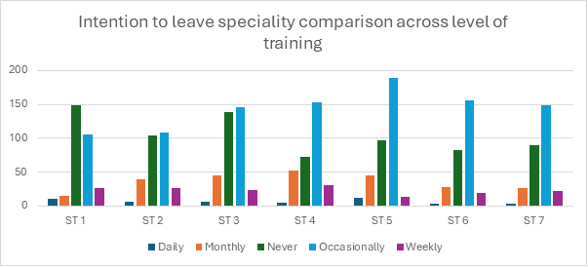
Figure 2 – Intention to leave speciality across levels of training

When considering the reasons selected for intention to leave the specialty, it is important to note that respondents were able to select all reasons which were applicable to them.

Across all respondents who expressed that they are seriously considering leaving the specialty, the most common reason given was lack of work-life balance (46.6%) (figure 3). This was followed by long working hours (35.8%), intense workload (35.6%), stress (30.5%) and shift working (28.6%). It is clear from this question that many trainees are struggling with their current shift patterns and 23.4% of respondents recognised that rota gaps were a contributing factor to intention to leave.

When compared to the 2024 TEF responses, the most common reasons for considering leaving the speciality remain similar, suggesting that there remains scope for improvement regarding reducing rota gaps and workload, and improving trainees’ work-life balance.

Although the most common reasons for considering leaving O&G have been considered above, there are some other selected factors which could seriously implicate an individual’s mental health and well-being. 6.4% of trainees cited lack of pastoral support, 3.4% cited poor educational support, 3.2% stated that there were no opportunities to debrief after a significant event and 2.5% of respondents cited racism as a reason for considering leaving the speciality. Reassuringly these numbers are relatively low, but these factors are important to consider. As discussed in the 2022 RCOG Workforce Report, meeting psychological needs is paramount to providing a supportive working environment, therefore it is crucial that ways to improve doctor support is further considered.
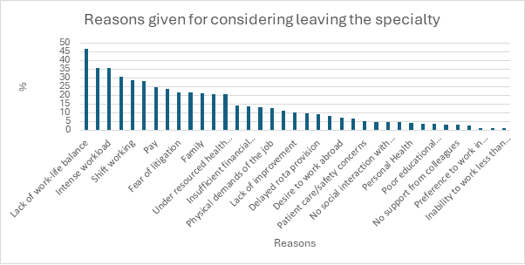Figure 3 - Reasons given for leaving speciality – all doctors.

Working patterns, rotas and working conditions
Designing rotas for staffing a 24-hour service is challenging, balancing service provision needs in addition to providing sufficient time off after out of hours (OOH) working. As 40.5% of the current O&G trainee workforce work LTFT (figure 4), rota design is becoming increasingly complex taking into consideration both annual and study leave requests in addition to meeting training requirements. It is also noteworthy that most trainees who work LTFT, work at 80%. This is equivalent to almost 40 hours per week, which is considered full-time (10PA) on a consultant or SAS contract. As the number of trainees choosing to work LTFT increases, consideration should be given to expanding the trainee workforce to account for the gaps in the whole time equivalent (WTE).

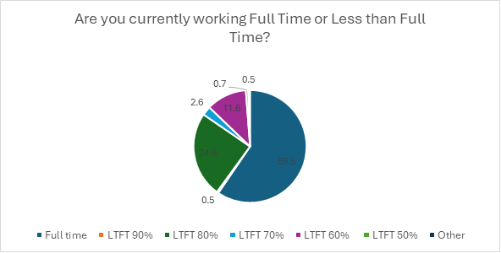Figure 4 - Displaying proportion of trainees working either Full Time or Less than Full Time

On call frequency
On call frequency is determined by the number of Whole Time Equivalent (WTE) doctors working at the same tier as the respondent. This means, as an example, that if a unit requires eight full time doctors to staff it then the on-call frequency should be reported as 1 in 8. There is also variation in the frequency of on call shifts worked by LTFT doctors, as some LTFT doctors may work a 100% on call frequency despite being employed at 0.8.

As there is such a wide variety in on call patterns reported by respondents (figure 5), it is possible that this question has been answered inaccurately. In agreement with the TEF 2024 report, this information could be better gathered from rota co-ordinators who have access to the rota structure. Additionally, if a large proportion of trainees are opting to work LTFT then this raises the question of whether the number of overall trainees should be increased to meet service demands and reduce the number of rota gaps.

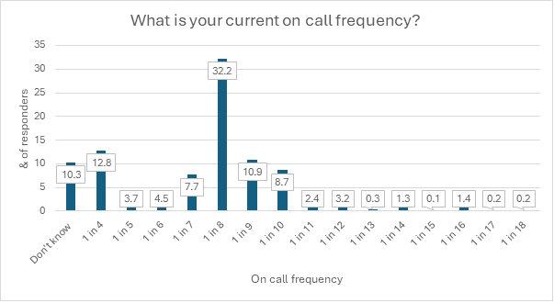Figure 5 – Chart displaying on call frequency.

Nights and weekends
Most trainees work four consecutive weekday nights (64%), with 16% working three nights and 15% of trainees working two. This question does not consider the different rota structure across units where some trainees may work more consecutive nights over the weekend.

When asked about how many sessions (one session = 0.5 days) trainees had off after working weekend days, 48.3% of respondents stated they had two sessions off, 14.7% reported no sessions off, 9.9% had 1 session, 1.2% said 3, 23% said 4 sessions and 2.9% reported >4 sessions. This question does not take into consideration that rest days may be issued to trainees prior to their weekend working. It would be interesting to know how many trainees are working on rotas which are not compliant with European Working Time Directive (EWTD).

% | I do not work these shifts | 1 | 2 |  | 3 |  | 4 |  | 5 |  | 6 |  | >6
2.17 After completing a set of consecutive weekday nights on call, how many nights of normal sleep would you have before you are next at work again? | 2.8 | 2.4 | 25 |  | 56 |  | 7.6 |  | 3.3 |  | 0.7 |  | 2.2
2.19 How many days off do you have after working consecutive weekend nights (not including the day after your shift finishes) | 2.4 | 38.5 | 30.6 |  | 8.3 |  | 6 |  | 2 |  | 6.3 |  | 5.9
23% of trainees never or rarely felt adequately rested returning to daytime duties after working consecutive night shifts. This is in comparison to 38% of trainees who felt often or always adequately rested, 36% of trainees sometimes felt adequately rested.

Most trainees responding to the survey did not feel safe to travel home following a shift, with 5.7% of trainees feeling “always” too tired, 16.6% often too tired and 35.9% sometimes feeling too tired to safely travel home. Some units provide “too tired to drive facilities” which were available to 29% of responders, not available to 14% of responders. 52% of responders did not know if such facilities were available in their unit.

Basic facilities
63% of respondents felt that they had access to adequate rest facilities during their night shifts (e.g. private area with bedding/ comfortable chair), however 37% of trainees reported that they do not have access to such rest areas. This is especially concerning considering that many trainees reported that they felt too tired to safely travel home.

% | Always | Often | Sometimes | Rarely | Never | N/A
2.21 If rest facilities are available during your night shifts, how often do you use such facilities? | 3.3 | 11.3 | 27.5 | 26.3 | 14 | 17
2.22 How often do you have at least 30 minutes of uninterrupted rest during a night shift? | 2.2 | 14.7 | 34.7 | 33 | 15.4

It should also be considered that there may be different basic facilities provided to trainees at different levels within the same unit.

Rota provision
9% of respondents had indicated that they had considered leaving the speciality due to delayed rota provision. 72% of trainees either agreed or strongly agreed that they had received their placement details 12 weeks in advance of starting their placement, in comparison to 63% who felt that they had received their personalised rota 6 weeks in advance. It could be that the process for recognising and trying to fill rota gaps in advance of August changeover is taking more time than anticipated, which suggests that the process for placements for changeover starts more promptly.

Fulfilling training requirements
Almost half (48.5%) of trainees report coming into work on off days or zero days to complete training requirements. In addition to this, many trainees do not have opportunities built into their average working week for non-clinical work (Figure 6) i.e., sessions for the purposes of audit, admin, projects, updating e-portfolio or private study.
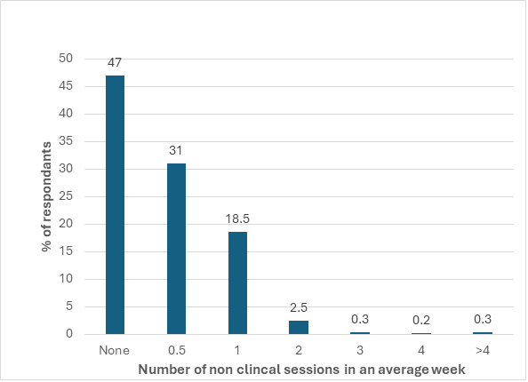
Figure 6 – How many non-clinical sessions do you have in your average working week?
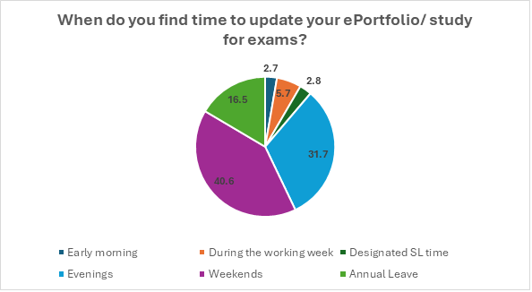It is also common that trainees lose non-clinical sessions to cover service clinical work. 31.8% of trainees “sometimes” lost these sessions 29% “often” lost them and 11.2% cited that they “always” lost them. Consequently, trainees are frequently using their own time for non-clinical tasks. The frequency in which these sessions are lost suggests that they are not adequately protected, or that there are frequent gaps with staff sicknesses requiring last minute cover with subsequent loss of these sessions.

Figure 7 – Chart examining when trainees found time to update e Portfolio/ study for exams.

Figure 8 – Chart examining how frequently non-clinical sessions are lost split between deaneries.

Exception reporting
Resident doctors in England can submit an exception report electronically for any variation from the planned working hours or training opportunities in their usual working pattern¹⁰. The purpose is to help identify areas of for improvement. For doctors working in Scotland, Wales or Northern Ireland a separate system exists (rota monitoring) where variation from normal working patterns can be identified¹¹.

40% of respondents agreed or strongly agreed that they felt supported to submit exception reports where appropriate, however 62% of trainees did not know that exception reports are used by trusts to improve training and 64.4% of trainees did not that exception reports are used to improve the delivery of patient care.

As previously identified, many trainees do not have time built into their rota for non-clinical work and submitting an exception report is another administrative task, which may in turn require trainees to stay further beyond contracted hours to submit such reports.

Support and workplace culture

Consultant support
84% of respondents knew that their unit had a policy for when a consultant must attend but 13% did not know if there was a policy and 2.1% said that their units did not have such a policy. Unfortunately, 3.8% of trainees reported requesting consultant presence under the conditions stated by their unit’s policy but the consultant did not attend.
In addition to this several trainees reported being asked to undertake clinical activities without what they considered to be appropriate supervision for their level of training. Interestingly a large proportion of trainees did not feel adequately supervised when working in theatre (figure 9). Lack of adequate clinical supervision is both a patient safety and training concern and should be explored in more detail to enable understanding of the situation.

Figure 9 - Graph identifying working environments without appropriate clinical supervision.

Educational supervision
81% of trainees were able to meet with their educational supervisor to set their personalised work schedule within two weeks of commencing their placement. This is commendable given the timing of rotations coincides with school and summer holidays. Most trainees (85.7%) felt that their induction meeting provided an effective assessment of their previous experience and current training needs and 87.5% of trainees felt that their supervisor knew them well enough to provide an overall assessment of their progress across the capabilities in practice.

Support after adverse events
21% of trainees stated that they had been involved in either a serious clinical incident, adverse or untoward event or poor outcome. Of these, 78.2% of trainees either agreed or strongly agreed that they felt well supported by the unit they were working in. However, this still leaves a considerable proportion who were involved in adverse events who did not feel well supported.

Workplace behaviours
Concerningly almost one third of trainees (30.5%) were either subjected to or witnessed behaviours that they would classify as “incivility” (Figure 10).

Figure 10 – Percentage of respondents who have either personally experienced or seen others subjected to poor workplace behaviours

There is a growing body of evidence that exposure to behaviours classified as “incivility” can have an impact on clinical performance. In our fast-paced speciality where we are frequently found managing an emergency in an operating theatre, being able to communicate effectively is essential for patient safety. Daniel Katz et al¹⁰ identified through a simulation study that exposure to incivility had a negative impact on performance, affecting vigilance, diagnosis, communication and patient management.
Furthermore, Cheetham and Turner¹¹ examined how an individual’s learning can also be affected by either experiencing or observing incivility. Exposure to these behaviours can contribute to stress, which detracts from our working memory and performance. Every day at work for O&G trainees provides opportunities to learn, extending into life as a consultant. As such we should all be working in a workplace that is psychologically safe and free from poor workplace behaviours.

Regional Workplace Behaviour Champions
69% of trainees reported being aware that their deanery had a regional workplace behaviour champion (RWBC) but only 34% knew who their RWBC was. Of the trainees who have contacted their RWBC, 80% found this to be helpful and 20% did not. This suggests that the RWBC network is a valuable but underutilised resource.

Wellbeing and work-related sickness
Over the course of the last six months 245 trainees (11.1%) have had time off for work related physical or mental health issues. The majority (72.7%) felt supported to take this time off, with the remaining trainees either feeling unsupported (14.2%) or preferred not to say (13.1%).

Figure 11 – Graph to demonstrate number of trainees taking time off work for work related physical or mental health issues.
To illustrate the significance of the impact of all absences on the service, the total estimated number of workdays lost is approximately 1467 over a six-month period. Calculations to reach this figure are available in Appendix B.
Many trainees felt that their working pattern may have contributed to their days of sickness or health concerns, with 19% agreeing and 41% agreeing in part. Other factors felt to have contributed to time off included workplace environment, colleagues, team dynamics and personal circumstances (Figure 12). This further highlights the need to improve workplace behaviours.

Figure 12 – Graph examining which other factors were perceived to contribute to having time off work due to sickness or health concerns.
The factor “Workplace environment” was examined in more detail and divided between deaneries. 7.2% of trainees who felt that their workplace environment had contributed to taking time off worked within Health Education and Improvement Wales. Next was HEE Northwest at 5% and HEE Wessex at 4.9%. There did not appear to be a correlation between the number of births per year at a unit and workplace environment which could suggest that individual’s experiences of a unit can vary vastly and perhaps there are other unmeasured factors contributing to their experience.

Burnout
Burnout remains a serious threat to the professional growth of O&G trainees and the health care system resilience. For the first time, the 2025 TEF survey implemented the Copenhagen Burnout Inventory (CBI) tool to identify trainees’ risk of burnout (high, moderate and low risk), using the seven work-related questions. This data has been used to measure prevalence by deanery and to test the relationship between work-related factors such as satisfaction with placement, sickness absence, retention, and workplace culture and the level of burnout.

Prevalence of Burnout
Overall, high burnout was observed in 15% of trainees, moderate burnout affected 47% and the remaining 39% were categorised as having low levels of burnout (Figure 13).

Figure 13 – Proportion of trainees identified as being at low, moderate or high risk of burnout

Figures 14 and 15 demonstrate the burnout prevalence by deanery. High burnout rates varied from 8% (HEE North East) to 19% (Health Education and Improvement Wales), whereas moderate burnout was between 32% (Wales) to 52% (HEE East of England). Low burnout varied from 33% (HEE North West London) to 49% (NHS Education and Improvement Wales). Most regions had 13-17% of their trainees affected by high levels of burnout and 45-50% affected by moderate levels of burnout.
Figure 14 – Burnout Prevalence by Deanery

Region | High | Moderate | Low | N
HEE East Midlands | 18% | 44% | 38% | 160
HEE East of England | 13% | 52% | 35% | 167
HEE Kent, Surrey & Sussex | 15% | 50% | 35% | 130
HEE North Central & East London | 16% | 47% | 37% | 148
HEE North East | 8% | 47% | 44% | 118
HEE North West | 14% | 46% | 40% | 280
HEE North West London | 17% | 50% | 33% | 117
HEE South London | 13% | 43% | 44% | 119
HEE South West | 13% | 51% | 36% | 137
HEE Thames Valley | 16% | 45% | 39% | 87
HEE Wessex | 15% | 48% | 37% | 81
HEE West Midlands | 17% | 44% | 38% | 169
HEE Yorkshire & Humber | 15% | 51% | 34% | 189
Wales | 19% | 32% | 49% | 69
Scotland | 11% | 46% | 43% | 171
Northern Ireland | 15% | 45% | 40% | 65
Total | 15% | 47% | 39% | 2207
Figure 15 – Table to demonstrate burnout levels across Deaneries

Burnout category by training year
High burnout was documented in the early–mid training years, 15.7% at ST1, peaking at 20.3% at ST3. It declined at senior levels to 10.4% at ST6 and 11.3% at ST7, where low burnout predominated (46.2% at ST6; 49.5% at ST7). Data from the post-CCT group were excluded from analysis due to small sample size and to protect participant anonymity.

Figure 16 – Burnout categories divided by speciality training year
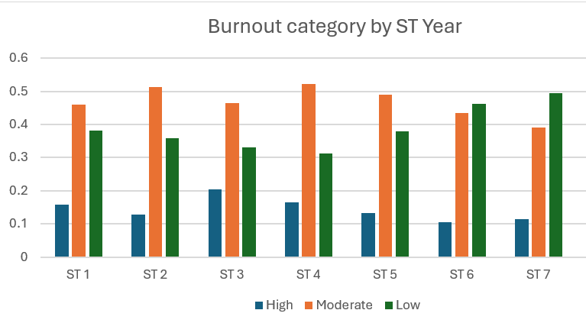

Burnout and associated work-related factors

Sickness Absence
The likelihood of sickness absence was also significantly correlated to burnout. (Cramer V = 0.13). In the high burnout group 20% of trainees had taken time off work, compared to 6% in the low burn out group and 12% in the moderate group.

Figure 17 – Time off in last 6 months

Consideration of Leaving the Specialty
Burnout and intention to leave the speciality was one of the most significant associations in the dataset. 95% of trainees in the low-burnout group said that they never or rarely thought about leaving. 4% of trainees occasionally considered it and 1% often thought about it. In comparison to the trainees in the high burnout group 32% frequently thought about leaving, 23% occasionally and 45% rarely considering it. Burnout is therefore a powerful indicator of retention risk, as highly burnout trainees were more than thirty times more likely to contemplate quitting than their lower-burnout counterparts.
Figure 18 – How often do you consider leaving the speciality?

Sense of Belonging and Feeling Valued
Community perceptions in training units declined drastically with an increase in burnout. Concurrence that the unit made the trainees feel a sense of community and belonging was 83% among those trainees with low burnout, 64% with moderate burnout and only 50% with high burnout. The disagreement in the low-burnout group was 5 percent and in the high-burnout group was 25 percent and neutrality was 12 percent to 26 percent. Perceptions of belonging were thus highly correlated with burnout, p = 0.001.
Figure 19 – Association between level of burnout and sense of belonging.
The sense of being valued at work was also affected by burnout (chi-squared p<0.001). 87% of trainees in the low burnout group felt valued at work, dropping to 68% for moderately burnt-out trainees and only 50% who were highly burnt out.

Recognition of Positive Behaviours
Interestingly there was an association between burnout and the recognition of positive behaviours. 90% of low burnout trainees said that they had observed positive behaviours compared to 85% in the moderate burnout group and 77% in the high burnout group. This could mean that highly burnout trainees are less likely to observe positive behaviours or that they are less likely to be aware of or experience behaviours that they would class as positive.
Figure 18 -Relationship between burnout levels and recognition of positive behaviour

Sexual harassment/ inappropriate sexual behaviours
The questions related to the incidence of inappropriate sexual behaviours were seldom reported; however, statistically significant correlation with the level of burnout (p < 0.05) was observed.
Among those with low burnout, 80% strongly disagreed that they had witnessed inappropriate sexual behaviours. Even in the high-burnout group, 73% reported not witnessing such behaviours. Personal experiences of inappropriate sexual behaviours were rarer still, affecting only about 1–2% of respondents.
Even though the prevalence of both witnessing and experiencing inappropriate sexual behaviours was low but statistically significant correlation between the high levels of burnout and the high prevalence of reporting the behaviours.

Figure 20: In this post I have WITNESSED inappropriate sexual behaviours

Figure 21: In this post I have EXPERIENCED inappropriate sexual behaviours

Undermining Behaviour
The likelihood of witnessing behaviour that undermined a colleagues confidence increased significantly with burnout levels, (P<0.001) observed by 11% in the low burn-out group and 29% in the high burnout group. Being personally undermined showed a similar trend with 8% reporting frequently experiencing such behaviour, 18% occasionally and 74% rarely.

Perceptions of Leadership
Trainees with a high burnout level were more like to perceive poor senior medical leadership with the inverse being true for trainees with low levels of burnout.
 | How often have you seen poor senior medical leadership skills demonstrated within your unit?
Burnout | Never/rarely | Occasionally | Always/often
Low | 77% | 19% | 4%
Moderate | 58% | 33% | 9%
High | 43% | 39% | 18%

Workload and Learning Needs
Strong correlations (p<0.001) were also observed between the level of burnout and perception that the work intensity was too high to learn. 10% of trainees in the low burnout group felt that the work intensity was too high, compared to 29% in the moderate group and 49% in the high burnout group. There is a likelihood that high workload can compromise meaningful learning.

Figure 22 – Workload and training requirements

Rota Gaps
The presence of rota gaps was strongly linked to higher burnout levels (P<0.05). Among trainees who reported rota gaps had higher proportions of burnout, with only 38% in low burnout, 48% in moderate, and 59% in high burnout. There was a small percentage of trainees in all groups unaware of rota gaps.

Figure 23: Correlation of burnout with rota gaps

Conclusion
The results show that burnout is not a single phenomenon but is closely connected with the satisfaction with the place of work, sickness absence, retention, workplace culture and leadership. Although most trainees report moderate burnout, the effects of high burnout are severe, such as less enjoyment, more sickness absence, a greater risk of leaving the specialty, and more exposure to negative behaviours in the workplace. Burnout is not a question of personal health only but also of the sustainability of the workforce. There should be system-wide interventions to enhance workload balance, supportive cultures, and leadership in training units.
As was cited by the GMC Duties of a Doctor, we should all be working within a supportive working environment⁷. Factors contributing towards creating a supportive working environment include meeting physical, psychological and self-actualisation needs⁴. There is a necessity to improve working conditions, providing our entire workforce with access to basic facilities, giving opportunities for flexible working conditions and supporting doctors returning to work. We should also consider how we can improve provision of psychological support for our doctors, shifting away from a “blame culture,” and providing support following adverse outcomes. Finally, it is important that units support work-life balance by ensuring that our trainees have sufficient opportunities and protected time for both training and learning withing working hours.

Limitations
This is the first year that the TEF survey has implemented the Copenhagen Burnout Inventory (CBI) tool. The data will become increasingly meaningful when trends over the years can be analysed.

Recommendations
Burnout is a complex condition which can be triggered by personal factors, as well as factors within the workplace. Trainees may be affected by burnout at different times throughout the course of their training, with each ST level bringing different challenges and demands as well as varying experiences within different units. Therefore, to improve wellbeing and reduce the risk of burnout, national organisations, trusts/health boards and individuals all have a role to play.
- It is important that trainees who request to work less than full time (LTFT) are supported to do so. As the proportion of LTFT working grows, it is crucial that the trainee workforce is expanded to account for the gaps in whole time equivalent (WTE).
- All trainees should have protected time for non-clinical tasks, including exception reporting which can add to the administrative burden.
- Trusts should ensure that all doctors have access to adequate rest facilities, during and after a shift. The Association of Anaesthetists have produced a fatigue tool to identify if someone is too tired to drive home; this should be promoted in all units.
- A large proportion of trainees did not feel adequately supervised when working in theatre. Lack of adequate clinical supervision is both a patient safety and training concern; this should be explored in more detail to enable understanding of the situation. All units should have a policy for when a consultant must attend, and all trainees should be made aware of this.
- Of those that had been involved in either a serious clinical incident, adverse or untoward event or poor outcome, 21.8% did not feel that they had been well supported by the unit. Each organisation delivering maternity and/or gynaecology services should commit to a programme to prevent and provide early intervention for work-related PTSS in all staff members as set out in the Prevention and Treatment of Work-Related Post-Traumatic Stress Symptoms in the Maternity and Gynaecology Workforce (Good Practice Paper No. 19).¹
- Trusts need to continue to promote positive workplace behaviours. A positive workplace environment can reduce the risk of defensive practise, high stress, burn-out and sickness. Trusts should work alongside Champions and the RCOG to promote their deanery’s regional workplace behaviour champion.
- All trainees should be supported to develop their non-technical skills; this is important for providing safe patient care and improving behaviours in the workplace. The RCOG could consider implementing a course that supports the development of these skills.
- All doctors should be supported to reduce their risk of burnout; individuals need to be empowered to take steps that support their own wellbeing and employers need to take a preventative approach to burnout by educating the workforce on burnout symptoms. Providing support to doctors identified as being at moderate risk of burnout is essential to prevent potential progression to a high-risk state.

References
- GMC National Training Survey 2025 - https://www.gmc-uk.org/-/media/documents/national-training-survey-2025-results-report-111657596.pdf. Accessed September 2nd 2025
- Bourne T, Shah H, Falconieri N, et al. Burnout, well-being and defensive medical practice among obstetricians and gynaecologists in the UK: Cross-sectional survey study. BMJ Open. 2019.
- Smith RP. Burnout in obstetricians and gynaecologists. Obstet Gynecol Clin North Am 2017; 44: 297–310.
- RCOG Workforce Report 2022 - https://www.rcog.org.uk/media/kz0mhttl/workforce-report-2022.pdf Accessed September 2nd 2025
- GMC Workforce Report 2024 – The state of medical education and practice in the UK - https://www.gmc-uk.org/-/media/documents/somep-workforce-report-2024-full-report_pdf-109169408.pdf Accessed September 17th 2025
- Copenhagen Burnout Inventory - https://www.carepatron.com/files/copenhagen-burnout-inventory.pdf Accessed 31st August 2025
- General Medical Council. The duties of medical practioners registered with the GMC - https://www.gmc-uk.org/professional-standards/the-professional-standards/good-medical-practice/the-duties-of-medical-professionals-registered-with-the-gmc Accessed 17th September 2025
- BMA Exception Reporting for Resident Doctors in England https://www.bma.org.uk/pay-and-contracts/working-hours/work-schedule/exception-reporting-for-resident-doctors Accessed 17th September 2025
- Rota Monitoring for Resident doctors in Northern Ireland, Scotland and Wales https://www.bma.org.uk/pay-and-contracts/working-hours/work-schedule/rota-monitoring-for-resident-doctors-in-northern-ireland-scotland-and-wales Accessed 17th September 2025
- Katz D, Blasius K, Isaak R, et al Exposure to incivility hinders clinical performance in a simulated operative crisis BMJ Quality & Safety 2019;28:750-757. https://qualitysafety.bmj.com/content/28/9/750.citation-tools. Accessed 10th September 2025.
- Cheethan L and Turner, c. Incivility and the clinical learner. Future Healthcare Journal 2020 June;7: 109 -111. https://pmc.ncbi.nlm.nih.gov/articles/PMC7296586/ Accessed 10th September 2025

Appendix A
The below tables show additional burnout risk associations.

Placement Recommendation 23.1.2
Burnout levels had a strong correlation with the likelihood of trainees to recommend their placement (chi-square <0.001). 85% of trainees with low burn out levels either agreed or strongly agreed that they would recommend their placements compared to 68% of moderate burnout levels and only 49% of trainees with high burnout levels.
A converse relationship is also observed with 24% of trainees with high burnout levels either strongly disagreeing or disagreeing that they would recommend their placement, 11% of moderate burnout levels and just 4% in the low burnout group.
 | I would recommend this placement to other trainees at my level
Burnout | Strongly disagree/Disagree | Neither agree nor disagree | Strongly agree/Agree
Low | 4% | 11% | 85%
Moderate | 11% | 21% | 68%
High | 24% | 27% | 49%
Figure 13 – Table demonstrating recommendations of placement
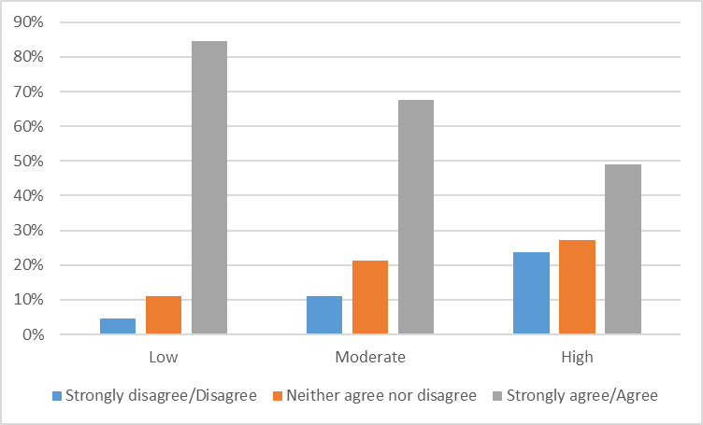
Figure 14 – Correlation of placement recommendation with burnout levels

Enjoyment of Placement
The enjoyment of their placement also appeared to be affected by burnout levels (chi <0.001). Most trainees with low burn out levels enjoyed their placements (90%) but just over half of trainees affected by high levels of burnout (56%) said that they had enjoyed working within their current unit.

Burnout | Strongly disagree/Disagree | Neither agree nor disagree | Strongly agree/Agree
Low | 3% | 8% | 90%
Moderate | 7% | 19% | 74%
High | 16% | 29% | 56%

Figure 15 – Link between Placement satisfaction and burnout levels

Appendix B
The below shows the calculations to reach the estimated number of workdays lost due to absences from service over a six-month period.
Number of days off work | Estimated mean | Responses | = mean x responses
0 – 1 | 0.5 | 45 | 22.5
2 – 3 | 2.5 | 65 | 162.5
4 – 7 | 5.5 | 48 | 264
8 – 10 | 9 | 19 | 171
- 10 | 11 | 77 | 847
 |  | Total | 1467

Appendix C
Below shows the list of questions from the 2025 TEF survey that were analysed in this report.
Working environment and rota
2.1 | Are there any gaps in the rota at your level of training in your current unit? | Yes | No | Don't know
2.2 | What type of ST1-2 level (including junior cover by other doctors e.g. Foundation & GP trainees) oncall rota does your unit have? | ST 1-2 level doctor on call for obstetrics and gynaecology only |  ST 1-2 level doctor on call for O&G and other specialities | Other [No free text option] | Don't know
2.3 | If ST1-2 oncall for other speciality please indicate which speciality | General Surgery | Orthopaedics | ENT | Urology | Paediatrics | General Medicine | Other [no free text option]
2.4 | What type of middle grade oncall rota does your unit have during the day, excluding consultant cover? | Single middle grade oncall rota with ST1-2 level cover (including junior cover by other doctors e.g. Foundation & GP trainees) |Single middle grade oncall rota without ST1-2 level cover (including junior cover by other doctors e.g. Foundation & GP trainees) |Two tier middle grade rota with one senior and one junior middle grade with ST1-2 level cover (including junior cover by other doctors e.g. Foundation & GP trainees) | Two tier middle grade rota with one senior and one junior middle grade without ST1-2 level cover (including junior cover by other doctors e.g. Foundation & GP trainees) | Two middle grades oncall working at the same level with ST1-2 level cover (including junior cover by other doctors e.g. Foundation & GP trainees) | Two middle grades oncall working at the same level without ST1-2 level cover (including junior cover by other doctors e.g. Foundation & GP trainees) | Other [no free text option] | Don't know
2.65 | What type of middle grade oncall rota does your unit have during the night, excluding non resident consultant cover? | Single middle grade oncall rota with ST1-2 level cover (including junior cover by other doctors e.g. Foundation & GP trainees) |Single middle grade oncall rota without ST1-2 level cover (including junior cover by other doctors e.g. Foundation & GP trainees) |Two tier middle grade rota with one senior and one junior middle grade with ST1-2 level cover (including junior cover by other doctors e.g. Foundation & GP trainees) | Two tier middle grade rota with one senior and one junior middle grade without ST1-2 level cover (including junior cover by other doctors e.g. Foundation & GP trainees) | Two middle grades oncall working at the same level with ST1-2 level cover (including junior cover by other doctors e.g. Foundation & GP trainees) | Two middle grades oncall working at the same level without ST1-2 level cover (including junior cover by other doctors e.g. Foundation & GP trainees) | Other [no free text option] | Don't know
2.6 | Is the senior middle grade resident or oncall from home at night? | Resident | Oncall from home | On site for a period of time then resident from home | No senior middle grade | Don't know | Other [no free text option]
2.7 | For how many days in the week is there a consultant resident overnight? | 0 | 1 | 2 | 3 | 4 | 5 | 6 | 7 | Other [no free text option]|Don't know
2.8 | There are appropriate arrangements made for covering consultant absence in outpatient clinics | Yes |No | Don't know
2.9 | Which clinical activities have you been asked to undertake for your level of training without what you consider to be appropriate consultant supervision? | Labour ward | Antenatal clinic | Gynae/outpatient clinic |Theatre | Planned caesarean birth list | Other | None
2.10 | Has your unit got a policy for when a consultant must attend? | Yes |No | Don't know
2.10.1 | Have you requested a consultant to attend under these conditions but they did not? | Yes |No
2.11 | To what extent do you agree or disagree with the following statements?
2.11.1 | The work intensity is too high for my learning needs | Strongly Agree | Agree | Neither Agree nor Disagree | Disagree | Strongly Disagree
2.11.2 | The work intensity is too low for my learning needs | Strongly Agree | Agree | Neither Agree nor Disagree | Disagree | Strongly Disagree
2.11.3 | I am allowed study leave for appropriate courses (i.e. not regional teaching) | Strongly Agree | Agree | Neither Agree nor Disagree | Disagree | Strongly Disagree
2.11.4 | I feel supported to submit exception reports when appropriate | Strongly Agree | Agree | Neither Agree nor Disagree | Disagree | Strongly Disagree
2.11.5 | How many exception reports have you submitted in the last six months | 0-1 | 2-3 |4-7 | 8-10 | >10
2.11.6 | Exceptions reports are used by my trust to improve training | Yes | No | Don't know
2.11.7 | Exceptions reports are used by my trust to improve the delivery of safe patient care | Yes | No | Don't know
2.12 | Are there any physician associates working in your department? | Yes | No | Don't know
2.12.1 | What tasks do they perform? | Assist in theatre| Bloods/Cannulation | Perform ECG | Ward jobs | Prepare discharge summaries | Assist in ward rounds | Shadowing | Outpatient clinic | Help oncall team | Clerking in maternity/emergency gynae/early pregnancy unit | MDT/M&M | Audit/research/QI | Other (please specify)
2.12.2 | Are there any other tasks that could suit them? Please list the tasks. | Assist in theatre| Bloods/Cannulation | Perform ECG | Ward jobs | Prepare discharge summaries | Assist in ward rounds | Shadowing | Outpatient clinic | Help oncall team | Clerking in maternity/emergency gynae/early pregnancy unit | MDT/M&M | Audit/research/QI | Other (please specify)
2.13 | Are there any tasks from your day to day work that could be delegated to another member of the team? | Yes | No | Don't know
2.13.1 | Who can you delegate these tasks to? Please select all that apply. | Nurse | Midwife | Advanced nurse practitioner |Physician associate | Other
2.14 | Do you have any additional comments you would like to make on your working environment and rota? (please do not share any names or personal identifiable information as part of your response - please note these comments may be shared with your HoS) | Free Text

Rotas and rest
2.15 | What is the on call frequency at your level of training? You should find this information on your work schedule or by seeing how many WTE doctors are on your tier of rota e.g. if 8 then then you are a 1:8. | 1:4 | 1:5 | 1:6 | 1:7 | 1:8 | 1:9 | 1:10 | 1:11 | 1:12 | 1:14 | 1:15 | 1:16 | 1:18 | 1:19 | 1:20 | Don't know | Other (please specify)
2.16 | How many consecutive weekday nights do you work? | 1 | 2 | 3 | 4 | 5
2.17 | After completing a set of consecutive weekday nights on call, how many normal nights of sleep would you have before you are next at work again? | 1 | 2 | 3 | 4 | 5 | 6 | >6 | I do not work weekday nights
2.18 | How much time off do you have immediately after working days over the weekend? (a session is defined as a morning or afternoon shift) | 1 session | 2 sessions | 3 sessions | 4 sessions | >4 sessions
2.19 | How many days off do you have after working consecutive weekend nights? (not including the day your shift finishes i.e. Monday day time) | 1 | 2 | 3 | 4 | 5 | 6 | >6 | I do not work weekend nights
2.20 | Do you have accessible and adequate rest facilities available during your night shifts (i.e. private area with bedding/comfortable chair)? | Yes | No
2.21 | If rest facilities are available during your night shifts, how often do you use such facilities? | Never | Rarely | Sometimes | Often | Always | N/A
2.22 | How often do you have at least 30 minutes of uninterrupted rest during a night shift? | Never | Rarely | Sometimes | Often | Always
2.23 | If applicable, do you ever feel too tired to safely travel home after a night shift? | Never | Rarely | Sometimes | Often | Always | N/A
2.24 | Do you have access to "too tired to drive" facilities after a shift if you need them? | Yes | No | Don't know | N/A
2.25 | How often do you feel adequately rested when returning to daytime duties after working consecutive night shifts (either weekday or weekend) within the current rota? | Never | Rarely | Sometimes | Often | Always
2.26 | Have you ever taken any time out of programme (OOP) for experience/training? (Please select all that apply) | Out of programme for clinical training | Out of programme for clinical experience | Out of programme for research | Out of programme for career break | Out of programme experience/training | Out of programme for research /training | No
2.27 | Within your average working week how many non-clinical sessions do you have? For audit, admin, projects, private study time (a session is defined as a morning or afternoon shift)? | 0 session | 0.5 session | 1 session | 2 sessions | 3 sessions | 4 sessions | >4 sessions
2.28 | How often are you asked to cover service clinical work during these "admin/ private study" sessions? | Never | Rarely | Sometimes | Often | Always
2.29 | When do you find time to update your ePortfolio/study for exams: | Early morning | During the working week | Evenings | Weekends | Designated study leave time | Annual leave
2.36 | Are you currently training Full time or Less Than Full Time (LTFT)? | Full time | LTFT 50% | LTFT 60% | LTFT 70% | LTFT 80% | LTFT 90% | Other (please specify)

Attrition
20.1 | Since starting specialty training how often have you seriously considered leaving O&G? | Daily | Weekly | Monthly | Occasionally | Never
20.1.2 | If you are currently considering, or would consider leaving the specialty, what reasons would you give? (Please select all that apply). | Family | Lack of work-life balance | Pay | Long working hours | Shift working | Intense workload | Rota gaps |Delayed rota provision | Desire to work abroad | Inability to work less than full time | Issues with gaining adequate clinical experience when working less than full time | Preference to work in another geographic area | Preference to work in another specialty | Personal Health | Physical demands of the job | Personal mental health | Stress | Lack of clinical supervision | Poor pastoral support | Poor educational supervision | Low morale | No support from colleagues | No social interaction with colleagues | Commuting distance | Frustration with training |Frustration with health service | Blame culture | Lack of improvement |Litigation | Fear of litigation | No opportunities to debrief following adverse event or serious incident | No support following adverse event or serious incident | Patient care/safety concerns | Concerns with new contract | Insufficient financial remuneration | Under resourced health service | Racism | N/A | Other (Please specify)
Burnout
21 | The following questions have been taken from the Copenhagen Burnout Inventory:
21.1 | Is your work emotionally exhausting? | Strongly Agree | Agree | Neither Agree nor Disagree | Disagree | Strongly Disagree
21.2 | Do you feel burnt out because of your work? | Strongly Agree | Agree | Neither Agree nor Disagree | Disagree | Strongly Disagree
21.3 | Does your work frustrate you? | Strongly Agree | Agree | Neither Agree nor Disagree | Disagree | Strongly Disagree
21.4 | Do you feel worn out at the end of the working day? | Always | Usually | Sometimes | Rarely | Never
21.5 | Are you exhausted in the morning at the thought of another day at work? | Always | Usually | Sometimes | Rarely | Never
21.6 | Do you feel that every working hour is tiring for you? | Always | Usually | Sometimes | Rarely | Never

Wellbeing
22.1 | Have you had time off work in the last six months for any work related physical health issues and/or work related mental health issues? | Yes | No | Prefer not to say
22.1.1 | Did you feel supported to have this time off? | Yes | No | Prefer not to say
22.1.2 | Have you been referred to occupational health? | Yes | No | Prefer not to say
22.1.3 | How many days off have you had for work related physical health issues and/or work related mental health issues in the last six months? | 0-1 | 2-3 |4-7 | 7-10 | >10
22.1.4 | Do you think your working pattern may have contributed to the days of sickness/health concerns? | Yes | Yes in part | Not at all | Prefer not to say | N/A
22.1.5 | What other factors contributed to the days of sickness/health concerns? (select all that apply) | Workplace environment | Colleagues | Team dynamics |Personal circumstances | N/A | Other (specify) | Prefer not to say


Find out more at

