Information for you
First published September 2016; updated XXXX 2025

Early miscarriage
About this information
This information is for you if you want to know more about miscarriage in the first 3 months of pregnancy. This is called an early miscarriage. It may also be helpful if you are a relative or friend of someone who has had an early miscarriage.
This information explains the signs that might be associated with early miscarriage, how it might be diagnosed and the care you will receive after an early miscarriage has been confirmed. For more information on bleeding and pain in early pregnancy, see the RCOG patient information Bleeding and/or pain in early pregnancy (https://www.rcog.org.uk/for-the-public/browse-our-patient-information/bleeding-andor-pain-in-early-pregnancy/)
Losing a baby is a deeply personal experience that affects people differently. You may need support afterwards. You can find further information and support from the Miscarriage Association at: www.miscarriageassociation.org.uk and from NHS Choices at: www.nhs.uk/conditions/miscarriage.
In this information we may use the terms ‘woman’ and ‘women’. However, we know that it is not only people who identify as women who may need to access this information. Your care should be appropriate, inclusive and sensitive to your needs whatever your gender identity.
A glossary of all medical terms is available on the RCOG website at: https://www.rcog.org.uk/for-the-public/a-z-of-medical-terms/
Key points
- Early miscarriages are very common and at least one in five women have a miscarriage for no apparent reason.
- Bleeding and/or pain in early pregnancy can be a warning sign of miscarriage and you should seek medical advice if you are experiencing this.
- If there is a possibility you are having a miscarriage, a health care professional may offer you tests including an ultrasound scan and/or blood tests to check your pregnancy.
- Once a miscarriage is diagnosed, your healthcare professional will discuss the options regarding your care with you.
- Most miscarriages are a one-off event, and there is a good chance of someone who has experienced a miscarriage having a healthy pregnancy in future.
What is an early miscarriage?
A miscarriage is an unplanned pregnancy loss before 23 weeks. If this happens to you in the first 13 weeks of pregnancy, it is called an early miscarriage. This means that your baby has stopped developing or has died. Most women who have a miscarriage experience vaginal bleeding and/or pain but sometimes there may be no symptoms. If this is the case, the miscarriage may be diagnosed by an ultrasound scan.
Why do early miscarriages happen?
In most cases, it is not possible to identify the reason for an early miscarriage. The most common cause is thought to be a problem with the baby’s chromosomes (the genetic structures within the baby’s cells). If this happens, the baby will not develop properly and the pregnancy may end in a miscarriage.
What are my chances of having a miscarriage?
Early miscarriages are very common. Many occur before a woman has missed her first period or before her pregnancy has been confirmed by a positive pregnancy test. In the first 13 weeks, at least one in five women will have a miscarriage.
Some factors can increase the risk of miscarriage such as:
- age – at the age of 30, the risk of miscarriage is one in five; over the age of 40, the risk of miscarriage is one in two
- certain medical conditions such as diabetes
- lifestyle factors such as smoking, being underweight or overweight, excessive alcohol drinking.
There is no evidence that stress or having sex during pregnancy can cause a miscarriage.
What should I do if I have bleeding and/or pain in early pregnancy?
Vaginal bleeding and/or pain in the early stages of pregnancy are common and do not always mean that there is a problem. However, sometimes bleeding and/or pain can be a sign of a miscarriage.
If you have any bleeding and/or pain, you can get medical help and advice:
- from your GP or midwife
- from your nearest early pregnancy assessment service. Details of the unit nearest to you can be found at: https://aepu.org.uk/find-a-unit/
- by calling 111, if you need medical help fast but it’s not an emergency. NHS 111 is a telephone advice service available 24 hours a day, 365 days a year, and calls are free from landlines and from mobile phones
- by calling 999 or going to the emergency department (A&E) at your nearest hospital if you are bleeding heavily, have severe pain or feel very unwell.
How is an early miscarriage diagnosed?
An early miscarriage is usually diagnosed by an ultrasound scan. A health care professional will offer you either a transvaginal scan (where a probe is gently inserted in your vagina) or a transabdominal scan (where the probe is placed on your abdomen) or both. Both types of scan are safe in pregnancy and do not increase your risk of having a miscarriage.
Your health care professional will discuss which type of ultrasound scan is suitable in your situation so that you can make an informed choice. A transvaginal scan may be recommended as it gives a clearer image.
You may be offered blood tests that could include checking the level of your pregnancy hormone (βhCG).
If you have bleeding or pain, your health care professional may ask to carry out an examination of your abdomen and/or your vagina using a speculum. An examination will only be done with your consent.
You should be offered a chaperone (another health care professional to support you) for an examination or a transvaginal scan. You may also wish to bring someone to accompany you.
For some women, the diagnosis of miscarriage can be made quite quickly but for others the confirmation and ongoing care may take several weeks.
Miscarriages can be described as:
- complete – the scan has found that there is no remaining pregnancy in your uterus
- incomplete –the scan has found some or all of the pregnancy is still in your uterus after having had bleeding
- missed – the scan has found that your pregnancy has stopped developing, but is still within your uterus. You may not have had any bleeding or pain
What happens if the scan shows an ongoing pregnancy?
If you have had bleeding and your scan shows that you have not had a miscarriage, and you have not had any previous miscarriages, you will be advised to start or continue your usual pregnancy care. If your bleeding gets worse or lasts more than two weeks, you should contact your healthcare professional or the early pregnancy unit again.
However, if you have had bleeding and you have had one or more miscarriages in the past, you will be offered treatment with progesterone. This is medication that you insert into your vagina or anus daily until you are 16 weeks pregnant. Progesterone can reduce the chance of another early miscarriage.
What are my choices if a miscarriage is confirmed?
If your ultrasound scan shows that your miscarriage is complete, you may not need any further treatment. Your health care professional will ask you to do a urine pregnancy test at home three weeks after your miscarriage. If the test is still positive, you should contact your health care professional or the early pregnancy unit for further care options.
If the miscarriage is confirmed but some or all of the pregnancy is still inside your uterus (incomplete or missed), your health care professional will discuss the options with you. You may choose to wait, to take medication or to have an operation.
Waiting for the miscarriage to happen by itself (expectant management of a miscarriage)
This means waiting for a miscarriage to happen by itself, without treatment. You will have some pain and bleeding as the pregnancy comes out of your uterus. Your health care professional may suggest this method for first 7 to 14 days after diagnosis of your miscarriage. You will be given information on what to expect, pain relief and who to contact if you have severe pain or heavy bleeding which may mean you need admission to hospital.
Your health care professional may offer a repeat scan after the 7 to 14 days of waiting if:
- you have not started bleeding and/or feeling pain
- the bleeding and/or pain are not going away
- the bleeding and/or pain are getting worse.
If the bleeding and pain have settled during the 7 to 14 days, you should do a home urine pregnancy test three weeks after your miscarriage. If it is positive, you should contact your health care professional or early pregnancy unit.
If you do not wish to wait for the miscarriage to happen by itself
If you do not wish to wait, your health care professional will discuss whether you would like to use medication or have an operation. These options may be more suitable for you and will be discussed with you if:
- you choose not to wait for the miscarriage to happen by itself
- you are at increased risk of bleeding or from the effects of bleeding (for example abnormal clotting disorder or unable to have blood transfusion)
- you may have an infection
- you have previous traumatic experience with pregnancy.
Taking medication (medical management of a miscarriage)
- If you have a missed miscarriage, you will be offered two types of medicine to take 48 hours apart:
- first medicine: mifepristone, taken by mouth
- second medicine: misoprostol, taken by mouth by or inserted into your vagina. The medication helps the cervix to open and lets the remaining pregnancy come out.
For most women, bleeding and pain will start within 48 hours after the second medicine. If it does not start, you should contact your health care professional to arrange further investigations and care.
- If your miscarriage is incomplete, you will be offered a single dose of misoprostol. This can be taken by mouth or inserted in your vagina.
When you are taking the medication, you will also be offered pain relief and anti-sickness medication. Some women may have diarrhoea and vomiting. Taking medication to complete a miscarriage does not involve local or general anaesthesia. Your health care professional will give you information on what to expect, pain relief and who to contact if you have increased pain or heavy bleeding . You will be advised to take a home urine pregnancy test three weeks after your miscarriage.
You should contact your health care professional if:
- the test is positive three weeks after your miscarriage
- you have severe pain
- you have heavy bleeding
- you feel unwell at any time, even if your pregnancy test is negative.
Having an operation (surgical management of a miscarriage)
The operation will be carried out under general or local anaesthesia.
The pregnancy is removed through the cervix. You may be given tablets to swallow or to be inserted in the vagina before the operation to soften your cervix.
Surgery will usually take place within a few days of your miscarriage but you may be advised to have surgery urgently if:
- you are bleeding heavily and continuously
- there are signs of infection.
The operation is safe but there is a small risk of complications including heavy bleeding, infection, or damage to the uterus (womb). A repeat operation is sometimes needed if the first one did not work. The risk of infection is the same if you choose medical or surgical treatment.
If your blood type is rhesus D negative, you will be offered an anti-D injection after your operation. See the NICE patient information Routine antenatal anti-D prophylaxis for women who are rhesus D negative, which is available at: www.nice.org.uk/guidance/ta156/informationforpublic.
For information on recovering after your operation, see the RCOG patient information Recovering from surgical management of a miscarriage (www.rcog.org.uk/en/patients/patient-leaflets/recovering-from-surgical-management-of-a-miscarriage).
What happens to the pregnancy?
Your health care professional may offer laboratory tests to provide more details about your pregnancy. The results can confirm that the pregnancy was inside the uterus and not an ectopic pregnancy (when the pregnancy is growing outside the uterus). Tests can also find out if there were any abnormal changes in the placenta (molar pregnancy). Your health care professional may advise genetic tests if you have had three or more miscarriages.
Options for burial or cremation will be discussed with you depending on your hospital and your own individual circumstances. You can also make your own arrangements through a funeral director or follow regulations for a home burial.
I would like to have a memorial for my baby. How do I organise that?
Many hospitals have a book of remembrance. Talk to your health care professional about the options at your hospital. Other ways to create a memory are available through the Miscarriage Association’s Memorial Certificate, Baby Loss Certificate in England and The Memorial Book in Scotland.
What happens next?
Vaginal bleeding
You can have some vaginal bleeding for one to two weeks after your miscarriage. This is like a heavy period for the first day or so. This should lessen and may become brown in colour. You will be advised to use pads rather than tampons, as using tampons could increase the risk of infection.
If you normally have regular periods, your next period will usually be in four to six weeks’ time. Ovulation can happen before this, so you can get pregnant in the first month after a miscarriage. Therefore, if you do not wish to become pregnant, you should consider using contraception.
Pain
You can expect some pain and cramping in your lower abdomen on the day of your miscarriage. You may get milder cramps or pain for a day or so afterwards. You can take painkillers to relieve the pain.
If you experience the following symptoms, you should seek medical advice from your GP, early pregnancy assessment service or the hospital where you had your care, or call NHS 111:
- heavy or prolonged vaginal bleeding
- smelly vaginal discharge
- abdominal pain not relieved by painkillers
- nausea and vomiting
- feeling unwell.

These symptoms may mean you have an infection of the lining of the uterus. It occurs in 2 to 3 in 100 women and can be treated with antibiotics. It may also mean that some of the pregnancy is still inside your uterus.
If you had an operation, these symptoms can sometimes mean there was a complication from the operation where there is a damage to the uterus. This is very rare, occurring less than 1 in 200 women.
Emotional recovery
A miscarriage affects every woman differently and can be devastating for her partner, friends and family too. Some women come to terms with what has happened within weeks; for others, it takes longer. Many women feel tearful and emotional afterwards. Some women experience intense grief.
There is support for you, your family and friends. Talking to your family and friends may be helpful. Talk to your GP if you feel you are not coping and need support with your mental health. You can find further information and support from:
- the Miscarriage Association at: www.miscarriageassociation.org.uk,
- NHS Choices at: www.nhs.uk/conditions/miscarriage
- Tommy’s: https://www.tommys.org/baby-loss-support/miscarriage-information-and-support/your-options-and-decisions
- Sands at: www.uk-sands.org.
Returning to work
When you return to work depends on you and how you feel both physically and emotionally. It is advisable to rest for a few days. Speak to your GP or occupational health adviser if you need further advice
Having sex
You can have sex as soon as you feel physically and emotionally ready. It is important that you are feeling well and that any pain and bleeding has significantly reduced. If you don’t want to become pregnant, consider using contraception.
When can we try for another baby?
You can try for a baby as soon as you and your partner feel physically and emotionally ready.
Am I at higher risk of a miscarriage next time?
You are not at higher risk of another miscarriage if you have had one or two early miscarriages. There is a good chance of having a healthy pregnancy in the future.
A very small number of women have a condition that makes them more likely to miscarry. If this is the case, medication may help. For further information, see the RCOG patient information Recurrent miscarriage (https://www.rcog.org.uk/for-the-public/browse-our-patient-information/recurrent-miscarriage/).
Is there anything else I should know?
If you are planning to have a baby, you should:
- take folic acid every day from when you start trying until 12 weeks of pregnancy to reduce the risk of your baby being born with a neural tube defect (spina bifida)
- be as healthy as you can – eat a balanced diet and stop smoking
- not drink alcohol as this may increase your chance of miscarriage (see the UK Chief Medical Officers’ Low Risk Drinking Guidelines, which is available at: www.gov.uk/government/publications/alcohol-consumption-advice-on-low-risk-drinking).
Further information
Association of Early Pregnancy Units (AEPU): aepu.org.uk
Human Tissue Authority (HTA): www.hta.gov.uk/faqs/disposal-pregnancy-remains-faqs
Miscarriage Association: www.miscarriageassociation.org.uk
National Institute for Health and Care Excellence (NICE): Ectopic Pregnancy and Miscarriage: www.nice.org.uk/guidance/cg154/ifp/chapter/About-this-information
NHS 111 service: www.nhs.uk/NHSEngland/AboutNHSservices/Emergencyandurgentcareservices/Pages/NHS-111.aspx
Royal College of Nursing: Managing the Disposal of Pregnancy Remains: www.rcn.org.uk/professional-development/publications/pub-005347
Sands: www.uk-sands.org
Tommy’s: https://www.tommys.org/baby-loss-support/miscarriage-information-and-support/your-options-and-decisions
Making a choice
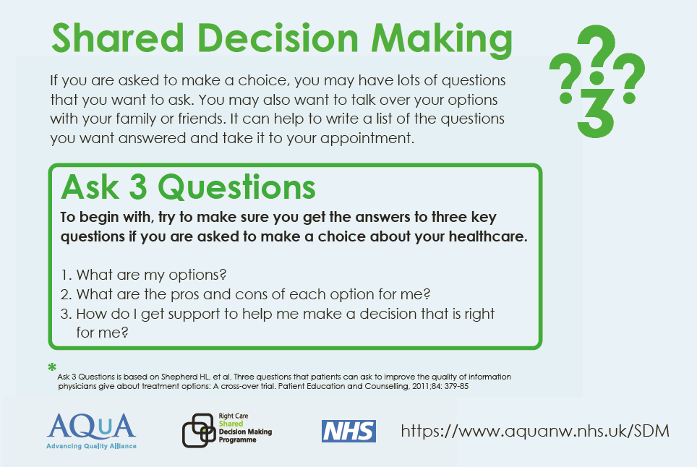
Sources and acknowledgements
This information has been developed by the RCOG Patient Information Committee. It is based on the NICE Guideline Ectopic Pregnancy and Miscarriage: Diagnosis and Initial Management, which you can find online at: https://www.nice.org.uk/guidance/ng126.
This leaflet was reviewed before publication by women attending clinics in Liverpool, Chester, Prescot and Wrexham, by the RCOG Women’s Network and by the RCOG Women’s Voices Involvement Panel.
The RCOG produces guidelines as an educational aid to good clinical practice. They present recognised methods and techniques of clinical practice, based on published evidence, for consideration by obstetricians and gynaecologists and other relevant health professionals. This means that RCOG guidelines are unlike protocols or guidelines issued by employers, as they are not intended to be prescriptive directions defining a single course of management.
A glossary of all medical terms is available on the RCOG website at: https://www.rcog.org.uk/for-the-public/a-z-of-medical-terms/.
A final note
The Royal College of Obstetricians and Gynaecologists produces patient information for the public. The ultimate judgement regarding a particular clinical procedure or treatment plan must be made by the doctor or other attendant in the light of the clinical data presented and the diagnostic and treatment options available. Departure from the local prescriptive protocols or guidelines should be fully documented in the patient’s case notes at the time the relevant decision is taken.
All RCOG guidelines are subject to review and both minor and major amendments on an ongoing basis. Please always visit www.rcog.org.uk for the most up-to-date version of this guideline.
© Royal College of Obstetricians and Gynaecologists 2016

