HIV and pregnancy

About this information

This information is for you if you are living with HIV (human immunodeficiency virus) and you are pregnant or planning to have a baby. If you are a partner, relative or friend of someone who is in this situation, you may also find it helpful.
The information here aims to help you better understand your health and your options for treatment and care. Your healthcare team is there to support you in making decisions that are right for you. They can help by discussing your situation with you and answering your questions.
Within this information we may use the terms ‘woman’ and ‘women’. However, we know that it is not only people who identify as women who may need to access this information. Your care should be appropriate, inclusive and sensitive to your needs whatever your gender identity.
A glossary of all medical terms is available on the RCOG website: https://www.rcog.org.uk/for-the-public/a-z-of-medical-terms/

Key points
- HIV is passed from person to person through body fluids such as blood and semen. It can also be passed from woman to baby during pregnancy and during breastfeeding. There is no cure for HIV but with effective treatment and careful monitoring, it can be managed so that people lead long, healthy lives.
- The risk of a woman passing HIV to her baby can be significantly lowered with safe treatment during pregnancy, at the time of birth and breastfeeding, with treatment for her baby in the first few weeks of life.
- Care for women with HIV in pregnancy is usually given by a specialist team who work closely together, including midwives, nurses and doctors who specialise in HIV and pregnancy. You will be able to discuss your choices for your care with them, including how to give birth and how to feed your baby so that you lessen the chance of passing HIV to your baby.

What is HIV?

HIV is a type of virus called a retrovirus that attacks the body’s immune system. HIV destroys the immune cells (CD4 cells) that help you to fight infection. This makes the immune system weaker. If you are living with the virus, this is known as being HIV positive. Acquired immune deficiency syndrome (AIDS) is the most advanced form of the infection. In the UK, most people being treated for HIV do not develop AIDS.

The virus can be passed from one person to another through blood, semen, vaginal fluids and breast milk.

How do I know if I have HIV?
All women should be offered a test for HIV in pregnancy. If the test is positive, you will be given support and offered referral to the specialist HIV team.

Some women know that they are already living with HIV when they get pregnant. With correct care, pregnancy will not change how HIV affects you. The pregnancy care team - including the doctors and midwives - will be seeing you regularly in collaboration with your HIV team.

What could HIV mean for my baby?

HIV can be passed on to your baby through the placenta while you are pregnant, during the birth and through your breast milk, if you decide to breastfeed.

Receiving personalised care during your pregnancy, birth and after your baby is born will reduce the chance of passing on HIV to your baby from about a 1 in 4 chance to less than 1 in 100.

What care can I expect during pregnancy?
You will be offered specialist care and regular health checks while you are pregnant. You should be cared for by a team of specialists that includes:
- a doctor who specialises in HIV
- a doctor who specialises in the care of pregnant women (obstetrician)
- a specialist midwife
- a doctor who specialises in children’s health (paediatrician).

You and your baby will be monitored during your pregnancy. This will include checking the amount of virus (viral load) and immune cells (CD4 lymphocytes) in your blood.

Scans
You will be offered the usual pregnancy scans: a dating scan at 11-14 weeks, and an anomaly scan to check for any physical problems at 18-21 weeks. As part of your routine antenatal care, some women may be offered growth scans in the second half of their pregnancies if there is an increased chance of having a small baby (read our information on having a small baby here). Your healthcare team will check your risk of having a small baby at your first booking appointment and as your pregnancy progresses.

Infection and vaccination
If you are HIV positive, it is important to know whether you have other infections that will need treatment or that can impact on the risk of transmission (passing HIV) to your baby.

Like other pregnant women, you will be offered blood tests in early pregnancy for hepatitis B, hepatitis C and syphilis. You will also be offered vaginal swab tests for sexually transmitted infections, such as chlamydia, gonorrhoea and trichomonas vaginalis, as well as common vaginal infections, including bacterial vaginosis and thrush. These swabs are usually done at the beginning of the pregnancy and repeated at 28 weeks.

All pregnant women are offered the whooping cough and RSV (respiratory syncytial virus) vaccines. You will also be recommended to have vaccinations for hepatitis B (if you are not immune), and covid and flu vaccines (in the autumn/winter months). These are safe in pregnancy.

Screening for Down’s, Edward’s and Patau’s syndromes
All women are offered a screening test for chromosomal differences (including Down’s syndrome) and this includes women living with HIV. If your test shows you are at increased chance of having a baby with one of these syndromes, you will be referred to a Fetal Medicine Unit to discuss your options.

Further tests such as amniocentesis may be recommended. Some of these tests can increase the chance of HIV transmission (passing HIV) to your baby. If you choose to have these tests, your healthcare team will want to make sure you have the lowest viral load possible to reduce this risk. You may need to take extra medication to lower your viral load and lower the risk of passing HIV on to your baby.

Should I have antiretroviral treatment (ART) in pregnancy?

Yes. The drugs used to treat HIV infection are known as antiretroviral treatment (ART) and everybody living with HIV is advised to take ART. This is to reduce their viral load, the risk of infections and transmission to their sexual partners. Your doctors will discuss ART with you, and will advise you to start medication as soon as possible in your pregnancy, and at no later than 24 weeks. This will help reduce the chance of passing the virus on to your baby. If you are already taking ART before pregnancy, do not stop taking it and get advice from your medical team.

Blood tests are needed to monitor your viral load and help your team decide on the best treatment for you. Sometimes this also means having a blood test to check the levels of the drug in your body. If you do not have ART there is a much greater risk that you will pass on the virus to your baby.

Is ART safe in pregnancy?

For you
Antiretroviral drugs (ART) are generally safe and have been used by millions of pregnant women. They can sometimes have side effects such as stomach and digestive problems, headaches and occasionally rashes, but for most women these symptoms are usually mild.

It is important to tell your doctor or midwife if you have any unusual symptoms while you are pregnant. Do not stop taking the medication without discussing it with your team first.

ART can sometimes cause liver problems. If you have started treatment in pregnancy you should be offered regular blood tests to check that your liver is working normally.

Some ART can affect how other medicines work, so it is important to let your medical team - including your GP - know about any other medications you are taking.

For your baby
ART is thought to be safe for your baby. Not taking the medication is much more likely to be harmful for your baby, because the risk of passing HIV to your baby will be much higher.

Which ART should I have?

You will be recommended to take the medication considered best for you.

If you are already taking ART

Your doctors will recommend that you continue ART during pregnancy and after you have had your baby. If you were taking ART before pregnancy you should not stop your medication. There may be a need to change some of your tablets, or the way you take them, to make sure what you take in pregnancy is the best option for reducing transmission to your baby.

- If you are not taking ART
You should start ART as soon as possible, usually in the first 3 months of your pregnancy, and by 24 weeks at the latest. The medicine and the blood tests that you need will be explained to you by your team. You will need to continue ART for the whole of your pregnancy and after your baby is born. If you come into hospital in labour when you have not been taking ART, you may be advised to have medication by a drip to help protect your baby during the birth and to start regular medication as soon as possible.

What are my options for birth?

Your team will discuss your birth options with you. They will consider:
- the result of your viral load tests
- whether you are on treatment or not
- any pregnancy complications
- your wishes about how you’d like to give birth.

Birth in hospital is advised so that the doctors can check your baby when they are born.

- You can have a vaginal birth if you are taking ART and have a viral load less than 50.
- If you are taking ART and your viral load is between 50 and 399 your doctors will recommend a caesarean birth to reduce the chance of passing HIV to your baby. This is usually at 39 weeks of pregnancy. Sometimes birth is advised earlier, depending on the pattern of your viral load results during your pregnancy and how long you have been on treatment.
- If you are taking ART and your viral load is 400 or more, you will be advised to have a caesarean birth, usually at 38 to 39 weeks. Your team will discuss the option of having two steroid injections to help lower the chance of breathing problems for your baby if birth is before 39 weeks. You can find out more about this from the RCOG Patient Information leaflet Corticosteroids in pregnancy to reduce complications from being born prematurely.

Whatever type of birth you choose, a sample of your blood should be taken at the time of the birth to check your viral load.

What happens if I have a caesarean birth?

If you are taking ART you should continue to take this as advised by your doctor.

If your contractions start before your planned caesarean birth you should call the hospital straightaway and come in. The caesarean will be done as soon as possible. Occasionally labour may be too far along, and it may be safer for you and your baby to have a vaginal birth.

If your pregnancy is complicated by other factors such as high blood pressure or a small baby, your birth may be planned for 37 to 38 weeks. Your team will discuss the option of having two steroid injections to help lower the chance of breathing problems for your baby. You can find out more about this from the RCOG Patient Information leaflet Corticosteroids in pregnancy to reduce complications from being born prematurely.

What happens if I have a vaginal birth?

You should continue your ART throughout your labour. As well as this, you may be advised to have medication by a drip, called zidovudine (a type of ART), if your waters have broken and your latest viral load is not known by the team, or if you are known to have a very high viral load.

If you go past your due date and your viral load is less than 50 it may be possible to have labour started (induced). The risks and benefits of this will be discussed by your team.

What if my waters break early?

After 37 weeks
- Planned vaginal birth: If your waters break before you go into labour and your viral load is less than 50 it may be possible to induce labour with a drip to start contractions. This will be started straightaway and you should not be advised to wait 24 hours for labour to start naturally.
- Planned caesarean birth: If your waters break before your planned caesarean birth you should call the hospital straightaway and come in. The caesarean birth will be done as soon as possible.
Before 37 weeks
If your waters break before your contractions start and before 37 weeks, your team will discuss with you whether it would be better for your baby to be born rather than waiting for labour to start naturally. This will depend on how far along you are in your pregnancy and your individual risk of passing HIV to your baby. You can find out more about this from the RCOG Patient Information leaflet When your waters break prematurely.

What treatment will my baby need after birth?

Your baby should be given ART within four hours of birth. This is usually given as a liquid. Your healthcare team will advise you how long your baby will need to take the medication. This will depend on the viral load in your blood test taken at birth. It is usually advised to give your baby ART for 2 to 4 weeks.

Your baby should be tested for HIV as soon as possible, within 24 hours of birth. The timing of further blood tests for your baby depends on your viral load taken at birth and how you plan to feed your baby. The tests are usually taken at either 2 or 4 weeks of age, and then will continue up until your baby is 22-24 months old.

What are my options for feeding my baby?

In the second half of your pregnancy, your team will discuss the options for how to feed your baby after birth. Giving your baby formula milk and no breast milk will make sure that HIV is not passed on from you to your baby.

However, some women, particularly if their viral load is less than 50, may choose to breastfeed and your team will support this. It is essential to continue your ART if you are breastfeeding. You should not combine breastfeeding with giving formula milk, as this can increase the risk of passing HIV to your baby. Your team will make a plan for you and your baby to have extra blood tests to monitor your viral loads. You will be advised to stop breastfeeding when you start mixed feeding (weaning), when your baby is 6 months old. For more information on HIV and feeding your newborn, see HIV and feeding your newborn baby and General information on infant feeding for women living with HIV.

Will anyone else be told about my HIV status?

Your healthcare team needs to be aware that you are living with HIV, so they can provide the best care possible for you and your baby.

The team should not tell anyone about your HIV status without your permission, including your GP and health visitors. However you will be encouraged to let them know in case you need ongoing medication after your pregnancy or if there are any complications with you or your baby’s health.

If you have not yet told your sexual partner that you are living with HIV, the team will encourage and support you to do so, in order to reduce the risk of passing on the HIV virus to them. Your team should respect your right to confidentiality and make sure that information is not disclosed to other people.

What should I do if I am planning to have a baby?

- You should discuss your plans with your HIV team to ensure you are on the right treatment and that you understand how to minimise the risk of you passing HIV to your partner while you are trying to become pregnant.
- You should be advised about safer sex practice and the use of condoms to prevent passing on HIV while you get blood tests done to check your viral load. If the viral load is undetectable and you are on treatment and taking your medication regularly, there is no risk of sexual transmission of HIV.
- You will be advised to wait until your viral load is low and to consider the use of HIV prevention medication by your partner, if he is not living with HIV. You may also be offered tests for sexually transmitted infections and treatment if needed.

All women are advised to take folic acid (0.4mg) for 3 months before they get pregnant. You will be advised by your HIV team to take the higher dose of folic acid (5mg) if you are taking certain medications

If your male partner is living with HIV and you are not, your team will ask his permission to get information about his care, including blood test results. The risk of transmitting HIV to the woman is zero if he is taking ART, has a viral load of less than 50 for at least 6 months and takes his medication regularly.

If you are considering assisted conception, you should discuss this with your fertility team as well as your HIV team.

Is there anything else I should know?

If you are living with HIV you should get contraceptive advice after you have had your baby.
Women living with HIV infection are recommended to have yearly cervical smear tests.

Emotional support
Having any medical condition while you are pregnant can be stressful. If you are feeling anxious or worried in any way, please speak to your healthcare team who can answer your questions and help you get support. The support may come from healthcare professionals, voluntary organisations or other services.

Further information and resources are available on the NHS website.

Further information and support organisations

British HIV association (HIVA) (bhiva.org)
BHIVA produce evidence-based information about HIV including Guidelines on the management of HIV in pregnancy and the postpartum period (2025)

There are charities and organisations that offer emotional, educational and practical support. If you like, they will put you in touch with other women who have been in a similar situation. Support organisations include:

Positively UK (positivelyuk.org)
Helpline: 020 7713 0444

Terrence Higgins Trust (tht.org.uk)
Helpline: 0808 802 1221

NAM (National Aids Map) (aidsmap.com)
Helpline: 020 3242 0820

Body & Soul (bodyandsoulcharity.org)
Helpline: 020 7923 6880

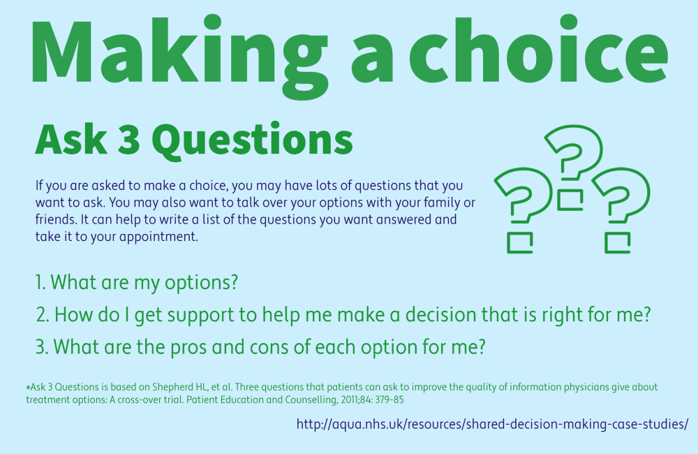

Sources and acknowledgements

This information has been developed by the RCOG Patient Information Committee. It is based on the RCOG guideline Management of HIV in Pregnancy (June 2010). The guideline contains a full list of the sources of evidence we have used. You can find it online at: http://www.rcog.org.uk/womens-health/clinical-guidance/management-hiv-pregnancy-green-top-39. It is also based on the BHIVA guideline: Guidelines for the management of HIV infection in pregnant women (2012) - http://www.bhiva.org/PregnantWomen2012.aspx and the NICE guideline: Fertility: Assessment and treatment for people with fertility problems (2012) - http://www.nice.org.uk/cg156

