
TEF Thematic Report
Gynaecological Training including Ultrasound

December 2025

T

Table of Contents

Background 3
Key Findings 3
Analysis 4
Procedural Skills 5
Basic Procedures 5
Intermediate Procedures 5
Advanced Procedures 7
Emergency Procedures 8
Office Procedures 9
Robotic Procedures 10
Simulation Training 12
Clinics 23
Supervision 26
Ultrasound Training 29
Transabdominal Ultrasound in Early Pregnancy 29
Transvaginal Ultrasound in Gynaecology 31
Transvaginal Ultrasound in Early Pregnancy 35
Discussion 39
Recommendations 40
Questions 41

Gynaecological Training

Authors: Dr Lavanya Venkatesh, ST1 trainee, HEE Wessex; Dr Olusola Abodunrin, ST5 trainee Health Education and Improvement Wales,
Supervision by: Dr Fiona Clarke Consultant Obstetrician and Gynaecologist, East Lancashire NHS Trust

Background

This report relates to the Training Evaluation Form (TEF) survey which is conducted annually by the RCOG to assess the quality of medical education and training across the UK. TEF 2025 was launched on 5 February 2025 and closed on 18 March 2025. Eligible participants were: Specialty Trainee | ACF | ACL | FTSTA | LAT | OOPT | OOPE | OOPR | OOPC| OOPP | OOPE/T | OOPR/T |SST.

The RCOG uses the results of the TEF survey to monitor and enhance the educational experience for doctors in training. Participation in TEF is mandatory and is a requirement of the training matrix of progression. Responses to the survey are treated confidentially and reported anonymously, allowing trainees to provide honest feedback about their training experience.

This report relates to the Training Evaluation Form (TEF) survey which is conducted annually by the RCOG to assess the quality of medical education and training across the UK. TEF 2025 was launched on 5 February 2025 and closed on 18 March 2025. There were 2,201 resident doctors in training (ST 1- 7) who responded to the TEF survey providing the data for analysis. This report will focus on analysing trainee experiences in gynaecology operating lists, simulation training, clinical supervision, clinics and ultrasound scan training.
The RCOG uses the results of the TEF survey to monitor and enhance the educational experience for doctors in training. Participation in TEF is mandatory and is a requirement of the training matrix of progression. Responses to the survey are treated confidentially and reported anonymously, allowing trainees to provide honest feedback about their training experience.

Key Findings
- Procedural Training: Early-stage trainees continue to face significant limitations in acquiring basic surgical skills, a trend observed over recent years. Exposure to intermediate procedures has improved, but advanced procedures remain suboptimal, with almost a third of trainees reporting dissatisfaction. This year’s inclusion of questions on robotic surgery highlights widespread regional variation in access and a perceived reduction in opportunities for conventional operative techniques.
- Simulation: Access to simulation remains inconsistent across deaneries and training levels, consistent with findings from the last two annual reports. High-fidelity resources are scarce, and some trainees report limited or no access. The combination of restricted access, inadequate feedback, and limited resources constrains opportunities for skill development and maintenance.
- Trainee Expectations and Career Decisions: Trainees generally expect to be competent in advanced gynaecological procedures by the end of their training; however, most express doubt that this is achievable within the current system. There does not appear to be a clear correlation between out-of-hours operating—whether in obstetrics or gynaecology—and the likelihood of trainees pursuing gynaecology-related surgical SITMs. This suggests a possible disconnect between trainees’ expectations, what is realistically achievable within current training structures, and the career choices being made. This gap warrants further exploration to better understand and align training opportunities with trainee aspirations.
- Clinic Exposure: Opportunities to attend general and specialist gynaecology clinics are insufficient across all stages, particularly for ST1–2 trainees. This limits essential learning from outpatient, patient-facing encounters and hinders the development of core clinical competencies.
- Supervision: Overall satisfaction with local supervision in elective theatre, clinics, and out-of-hours settings remains high. However, confidence in achieving curriculum requirements declines with seniority, likely reflecting the structural barriers identified in procedural, simulation, and clinic access.
- Ultrasound Training: Training opportunities for transabdominal and transvaginal ultrasound remain limited, particularly at early stages of training. Northern Ireland continues to provide comparatively better access for both training and skill maintenance, highlighting persistent regional disparities across the UK.

Analysis

Procedural Skills

Basic Procedures
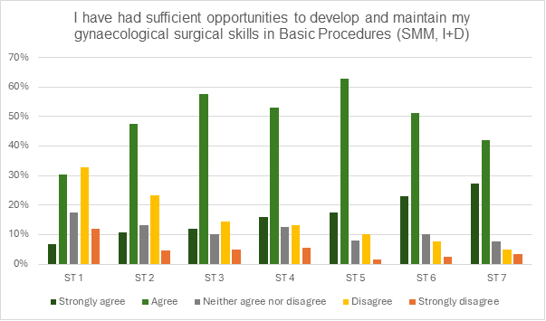
Figure 1: “I have had sufficient opportunities to develop and maintain my gynaecological surgical skills in Basic Procedures (SMM, I+D)”
It is concerning that 45% of ST1 trainees reported disagreeing or strongly disagreeing that they have adequate opportunities to develop and maintain basic gynaecological surgical skills. This represents a slight deterioration compared with last year, when 43% of ST1 trainees reported the same concern.
While perceptions of opportunity improve with seniority, with advanced trainees reporting the highest levels of overall satisfaction, this positive trend does not negate the underlying issue. If trainees are not equipped with core surgical skills during ST1 and ST2, it creates a lag in development that may extend into later stages of training.
These findings underscore the ongoing need for structured and equitable access to foundational surgical experience early in the training pathway.

Intermediate Procedures
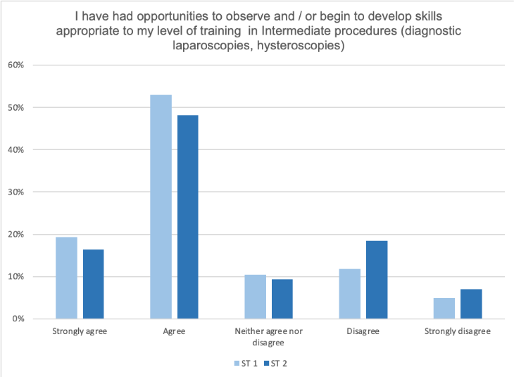
Figure 2: I have had opportunities to observe and / or begin to develop skills appropriate to my level of training in Intermediate procedures (diagnostic laparoscopies, hysteroscopies) – responses from ST1s and ST2s
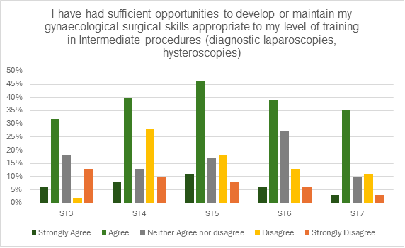
Figure 3: Proportion of Stage 2 and Stage 3 trainees (ST 3-7) who had sufficient opportunities to develop or maintain gynaecological surgical skills appropriate to my level of training in intermediate procedures

Looking at Figures 2 and 3, intermediate procedures such as diagnostic laparoscopies and hysteroscopies follow a different pattern. More than half of ST1 and ST2 trainees report agreeing or strongly agreeing that they have sufficient opportunities to develop these skills.

Interestingly, this perception declines as trainees progress into Stage 2 training. Nevertheless, there has been improvement: 38% of ST3, 48% of ST4, and 58% of ST5 trainees now report adequate intermediate training, with disagreement levels dropping to 15%, 38%, and 26%, respectively.

Advanced trainees report lower agreement than Stage 2 trainees, with disagreement at approximately 19% for ST6 and 14% for ST7, figures comparable to 2024. Despite this, both represent a notable improvement from previous years, highlighting some progress in intermediate procedural training.

Advanced Procedures
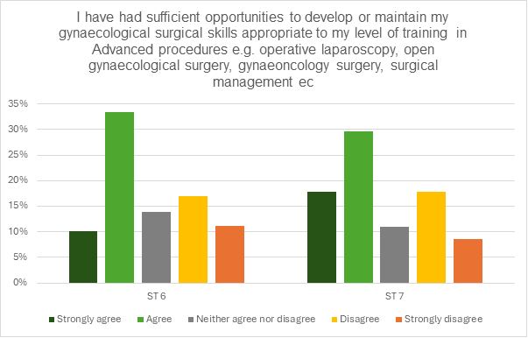
Figure 4: Responses from advanced trainees (ST 6- ST7) on "I have had sufficient opportunities to develop or maintain my gynaecological surgical skills appropriate to my level of training in Advanced procedures
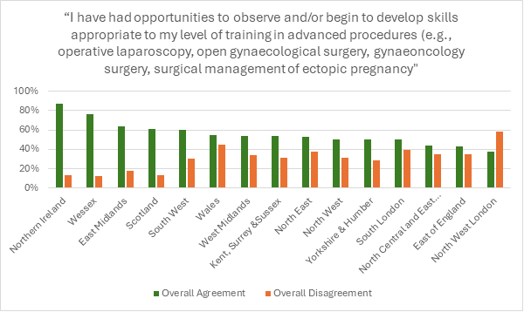
Figure 5: “I have had opportunities to observe and/or begin to develop skills appropriate to my level of training in advanced procedures – responses from ST6 and ST7 trainees broken down by deanery.

Just under a third of trainees’ report dissatisfaction with opportunities to observe or begin developing skills in advanced procedures, with 28% of ST6 and 26% of ST7 trainees disagreeing or strongly disagreeing (see Figure 4). This represents a modest improvement compared with last year, when 39% of ST6 and 32% of ST7 trainees reported the same. While 33% of ST6 trainees agree they have received adequate opportunities, the combined agreement (agree + strongly agree) for ST7 remains at 47%, a similar result to last year.

Figure 5 highlights significant geographic inequities in advanced surgical training. Regions such as Northern Ireland, Wessex, and East Midlands report high levels of agreement, indicating strong exposure to complex procedures.
In contrast, many major training regions, particularly across London and the East of England, show low levels of satisfaction. This disparity places senior trainees in underperforming deaneries at risk of qualifying without sufficient competency in essential advanced skills, including operative laparoscopy and the surgical management of ectopic pregnancy. Exploring whether successful strategies from regions such as Northern Ireland, Wessex, and East Midlands can be adapted and incorporated into lower-performing deaneries may help reduce these inequities, enhance trainee experience, and support readiness for consultant practice, ultimately safeguarding the future provision of gynaecological services and training opportunities.

Emergency Procedures

Figure 6 demonstrates responses regarding training in emergency gynaecological procedures across training levels. Overall agreement (combining 'Strongly agree' and 'Agree') was highest among ST2 and ST5 trainees at approximately 66% and 67%, while ST1 and ST7 reported lower combined agreement rates of around 54% and 62%.
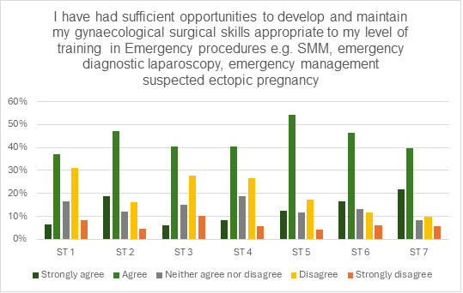
Figure 6: I have had sufficient opportunities to develop and maintain my gynaecological surgical skills appropriate to my level of training in emergency procedures e.g. SMM, emergency diagnostic laparoscopy, emergency management suspected ectopic pregnancy
These findings suggest that, while most trainees feel they have sufficient opportunities, two key groups face challenges in developing emergency surgical skills. These groups are ST1 trainees who are just beginning specialty training, and ST3 trainees who balance heavy obstetric and labour ward commitments.

Office Procedures
Figure 7 reveals a pronounced lack of opportunity for outpatient gynaecological procedures, particularly among early-stage trainees. A large majority of Stage 1 trainees report disagreement with having sufficient experience.
While satisfaction improves modestly by Stage 3, a substantial proportion of even the most advanced trainees continue to express dissatisfaction. This indicates that access to essential office-based procedures remains inadequate throughout training.
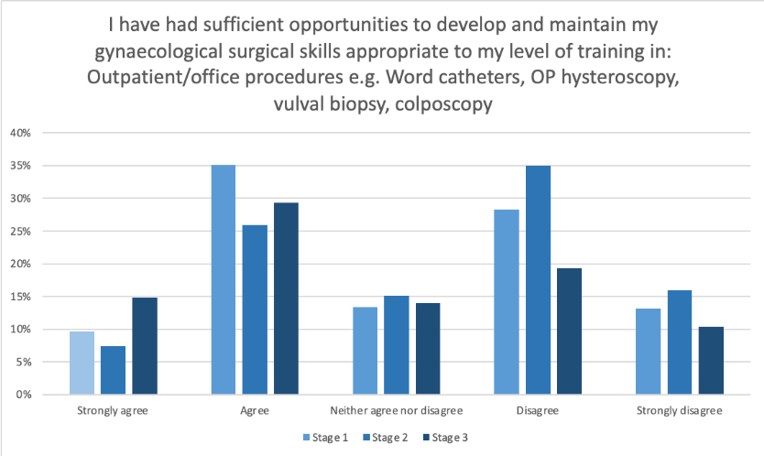
Figure 7: I have had sufficient opportunities to develop and maintain my gynaecological surgical skills appropriate to my level of training in: Outpatient/office procedures e.g. Word catheters, OP hysteroscopy, vulval biopsy, colposcopy

Robotic Procedures
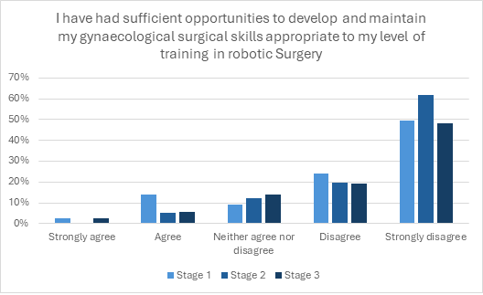
Figure 8: I have had sufficient opportunities to develop and maintain my gynaecological surgical skills appropriate to my level of training in robotic surgery broken down by stage of training
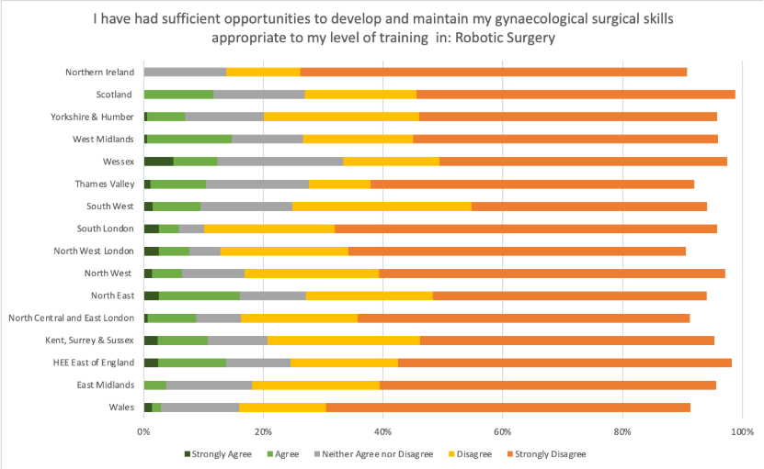
Figure 9: Robotic Surgery Training Opportunities by Deanery

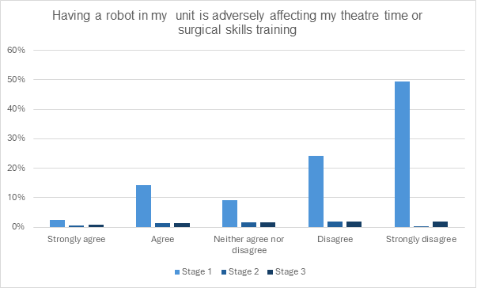
Figure 10: Having a robot in my unit is adversely affecting my theatre time or surgical skills training

This is a new question in this year’s survey. Figure 8 demonstrates that opportunities to develop robotic skills remain extremely limited across all training stages. Most trainees disagreed or strongly disagreed that they have sufficient opportunities for robotic training. Although exposure improves slightly by ST3, it remains inadequate overall, indicating that robotic surgery is not yet a standard or widely accessible component of the surgical curriculum.
Similarly, Figure 9 shows that opportunities to develop robotic skills remain limited across the country. It is also important to note that the robotic training requirements within the curriculum are not clearly defined, except for those undertaking the Robotic Surgery Special Interest Training Module (SITM). As only SITM trainees are expected to gain hands-on robotic experience, the question could be more precisely worded to reflect this distinction. For other trainees, the primary objective may be to gain awareness and understanding of the role of robotics, rather than proficiency. This question may therefore benefit from refinement in next year’s survey, as the current phrasing is broad and does not specify what constitutes adequate exposure.
Figure 10 indicates that the presence of a robot within a unit does not appear to reduce trainees’ access to overall theatre time or opportunities for conventional surgical training. This finding is noteworthy—and reassuring—as it suggests that the integration of robotic surgery has not adversely affected broader training opportunities. Although robotic procedures are often expected to be consultant-led due to their novelty and complexity, this does not seem to be reflected in the current data. In many units, the robot is still being newly introduced, with consultants themselves in the process of learning and consolidating their skills in its use.
It is important to note, however, that 90% of trainees did not respond to this question, including the majority of stage 2 and stage 3 (intermediate and advanced) trainees. This makes the findings difficult to interpret. The low response rate may reflect the fact that many units still do not have access to a robot, or alternatively, that intermediate and advanced trainees are not routinely scheduled for robotic lists and therefore do not perceive it as impacting their training. In future surveys, refining this question to clarify these possibilities may improve interpretability.

Simulation Training

How is simulation training provided in your region?
The survey showed that simulation training is delivered through a range of methods across the deanery, with no consistent or standardised model in place. The most reported formats were regional teaching days (23%) and out-of-hours (OOH) simulation within individual units (17%). Ad hoc sessions and deanery-run courses followed (both 14%), while in-hours simulation within clinical units was the least reported (8%).
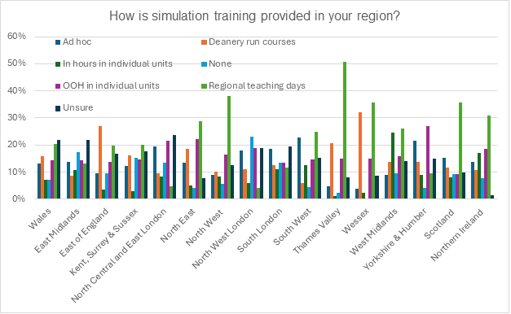
Figure 11: How is simulation training provided in your region?
Access appears to improve with training seniority. Regional and OOH simulations were more frequently reported in ST5–ST7, suggesting that opportunities increase later in the programme. Conversely, earlier stages, particularly ST1 and ST3 had the highest number of respondents indicating they were unsure about provision, highlighting gaps in communication or visibility of simulation opportunities.

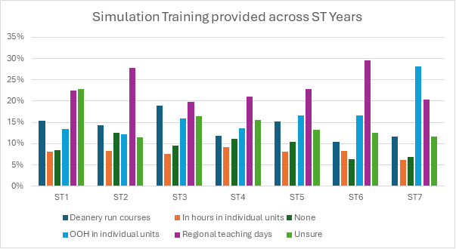 Figure 12: Simulation Training provided across ST Years
Alarmingly, 9% of trainees reported no access to simulation at all, most notably in ST4 and ST5. This raises concerns about equity, as simulation is increasingly recognised as a critical component of clinical training. Overall, the data point to a fragmented and inconsistent approach to simulation delivery. Improving standardisation, transparency, and early access, particularly through structured and in-hours opportunities, will be essential to ensuring equitable and effective training across all deaneries.

What simulation equipment is available for use in your unit?

Simulation resources across units remain basic, with limited access to advanced technologies. Shared box trainers were the most commonly available equipment, reported by 46% of trainees. Individual box trainers were less common (11%), and access to higher-fidelity tools was extremely limited; only 2% reported having box trainers with virtual reality, 5% had access to a simulation hub, and VR headsets were reported by just three trainees across all grades.
Access was also inconsistent across training years. ST3 and ST5 reported the highest number of shared box trainers, while ST1 and ST2 had high numbers of trainees, indicating either no access or uncertainty about available equipment. These figures point to poor communication or a lack of visibility around simulation resources, particularly in earlier stages of training.
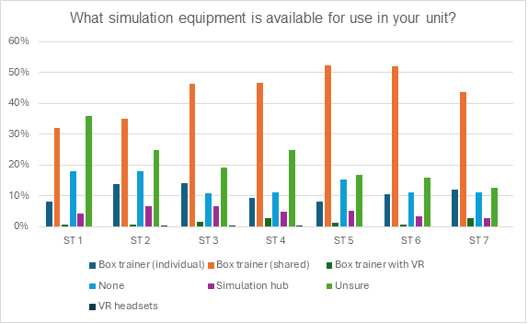
Figure 13: What simulation equipment is available for use in your unit?
Overall, 14% of trainees reported having no access to simulation equipment, and 22% were unsure of what was available in their unit. These findings reflect a continued reliance on low-fidelity tools and highlight gaps in equitable access and information, potentially undermining efforts to deliver consistent technical skills training across the deanery.

I have easy access to simulation equipment
Access to simulation equipment among trainees varied significantly across training levels. Approximately 43% of trainees reported having easy access, while 40% disagreed, indicating they did not have sufficient access. Around 30% remained neutral, reflecting uncertainty or inconsistent experiences.
Further analysis showed that junior trainees (ST1–ST3) expressed higher levels of dissatisfaction, with a greater proportion providing negative responses and fewer reporting easy access. In contrast, senior trainees (ST6–ST7) reported better access, demonstrated by more positive responses and fewer negative ones. The consistently high neutral response rate across all stages suggests widespread inconsistency in equipment availability.
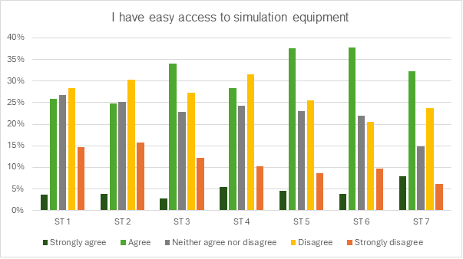
Figure 14: I have easy access to simulation equipment
These findings highlight significant disparities in access to simulation equipment between training sites, which could affect the consistency and quality of training. Addressing these inequities is essential to ensure all trainees have equitable opportunities to benefit from simulation resources.

I have access to feedback during simulation training
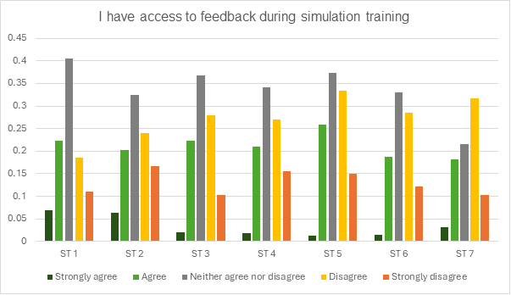
Figure 15: I have access to feedback during simulation training

The findings revealed that structured feedback is a weak point in current simulation training. Neutral responses were the most common, averaging around 40% across training levels, with trainees uncertain whether they consistently received useful feedback during sessions. Approximately 28% agreed that feedback was available, but 22% disagreed. Strong agreement never exceeded 10% of responses, while strong disagreement was consistently present. Overall, this shows that even when simulation training occurs, the educational value is undercut by inconsistent supervision and a lack of feedback.

I feel that on completion of training, all O&G trainees should be competent to perform advanced gynaecological procedures

There was a strong consensus among trainees that all O&G trainees should be competent in advanced gynaecological procedures, such as hysterectomy and myomectomy, upon completing their training. Over 80% of respondents across all training years agreed or strongly agreed with this statement. In contrast, fewer than 15% expressed disagreement.
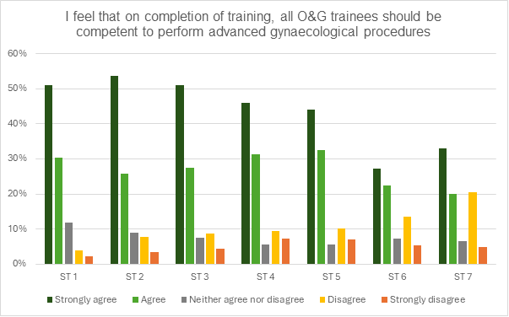
Figure 16: I feel that on completion of training, all O&G trainees should be competent to perform advanced gynaecological procedures
This widespread agreement underscores trainees’ high expectations and aspirations for their surgical competence at the point of completion of training emphasising advanced procedural skills as a fundamental outcome of their training.

I feel that it is realistic to train all O&G trainees to be competent in advanced gynaecology operating within the current system

Fewer than 30% of trainees agreed or strongly agreed that it is realistic to train all O&G trainees to competency in advanced gynaecological procedures within the current system. In contrast, over 50% disagreed or strongly disagreed. Notably, strong disagreement increased with seniority, surpassing 40% among ST6 and ST7 trainees. This trend highlights a widening gap between the optimism of junior trainees and the growing scepticism of senior trainees regarding the feasibility of universal advanced procedural competence under the current training model.

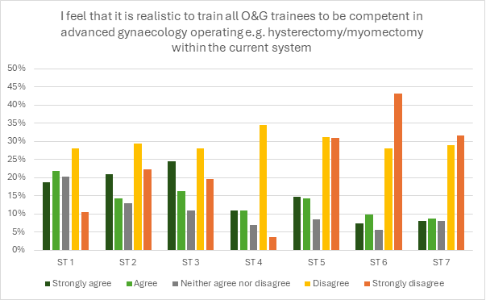
Figure 17: I feel that it is realistic to train all O&G trainees to be competent in advanced gynaecology operating e.g. Hysterectomy/ myomectomy within the current system

I plan to undertake an SITM/SST that would enable me to be competent in advanced gynaecological procedures

There was notable regional variation in how concerns about competency in out-of-hours gynaecological operating influenced trainees' SITM/ATSM choices. In HEE North West, over 50% of respondents agreed or strongly agreed that these concerns influenced their decision (112 out of 272 responses). Similarly high levels of agreement were seen in HEE West Midlands (49%) and HEE Yorkshire & Humber (48%).

Moderate influence was observed in East Midlands (43%), East of England (44%), and Kent, Surrey & Sussex (49%). In contrast, regions such as Wessex, Thames Valley, and Northern Ireland reported lower levels of agreement, with fewer than 40% of respondents influenced. Across nearly all regions, 20–30% of trainees selected “Neither agree nor disagree,” particularly in larger deaneries such as HEE Northwest, Yorkshire & Humber, and Scotland, suggesting variation in individual experiences and access to operative training. These results indicate that concerns about out-of-hours surgical competence remain a significant factor shaping career pathways, with regional disparities in training exposure contributing to variation in trainee confidence.
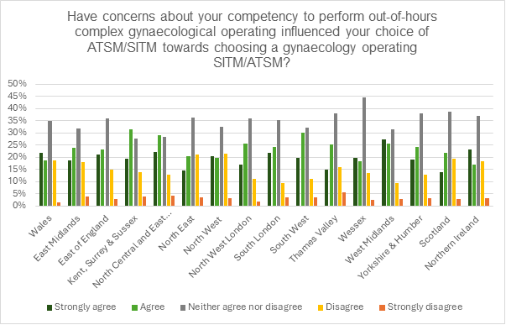
Figure 18: Have concerns about your competency to perform out-of-hours complex gynaecological operating influenced your choice of ATSM/SITM towards choosing a gynaecology operating SITM/ATSM?

A substantial proportion of trainees across all levels plan to, or are currently undertaking, a Special Interest Training Module (SITM) or Subspecialty Training (SST) focused on achieving competency in advanced gynaecological procedures. Agreement tends to be higher in mid-training years (ST3–ST5), with ST3 showing the strongest intent (over 60% positive responses). Earlier and later stages (ST1 and ST7) show slightly lower levels of commitment, possibly reflecting early career uncertainty and nearing completion of training, respectively. Neutral responses remain relatively high, indicating some trainees are undecided or exploring options.
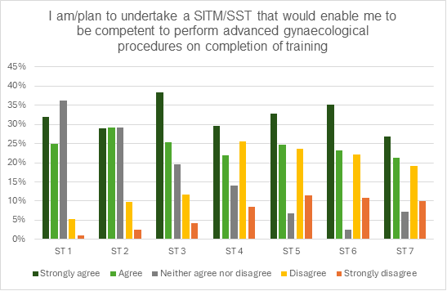
Figure 19: I am/plan to undertake a SITM/SST that would enable me to be competent to perform advanced gynaecological procedures on completion of training

Have concerns about your competency to perform out-of-hours complex gynaecological operating influenced your choice of ATSM/SITM?

56.4% of trainees currently/plan to undertake a SITM/SST that would enable them to be competent to perform advanced gynaecological procedures on completion of training (5.3.8) - i.e. agree or strongly agree responses only.

- 17.6% of the above disagree/strongly disagree that they are on track to fulfil their training requirements for the year in gynaecology (5.6)

- 25.4% of trainees who are not undertaking/plan to undertake SITM/SST that would enable them to be competent to perform advanced gynaecological procedures on completion of training disagree/strongly disagree that they are on track to fulfil their training requirements for the year in gynaecology

This shows that there is slightly more dissatisfaction in trainees not undertaking or planning to undertake gynae SITM/SST for the specific variable of being on track to fulfill their training requirement for the year under study.

This is understandable because of the competition for getting these training opportunities and it is very likely those undergoing gynae SITMS would be prioritised.

Across all training levels, neutrality was the most common response, accounting for nearly 45% of answers, suggesting some trainees are uncertain about how these concerns have influenced their decisions. However, around 35% of trainees reported that concerns about their surgical competency had influenced their decisions, with agreement particularly prominent with ST3 and ST5. Around 20% disagreed, suggesting a smaller group did not let these concerns influence their selection. These findings show that anxieties about surgical readiness play an important role for a substantial proportion of trainees when considering ATSMs or SITMs.

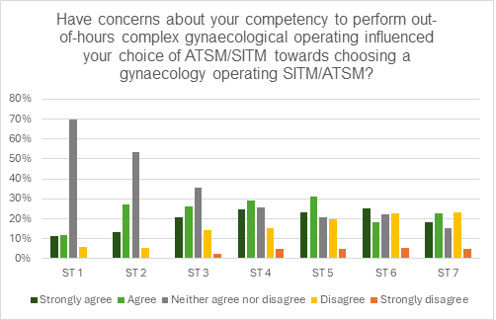
Figure 20: Have concerns about your competency to perform out-of-hours complex gynaecological operating influenced your choice of ATSM/SITM towards choosing a gynaecology operating SITM/ATSM?

Have concerns about your competency to perform out-of-hours complex obstetric operating influenced your choice of ATSM/SITM?

The survey indicates trainees are generally less influenced by concerns about out-of-hours obstetric operating competency when choosing a gynaecology-focused SITM/ATSM, compared to gynaecological operating concerns. Agreement is moderate in early to mid-training (ST2–ST4) but declines notably in senior trainees (ST5–ST7). A significant number of trainees disagree or are neutral, indicating that obstetric concerns are less of a driving factor in selecting a gynaecology-oriented training pathway.

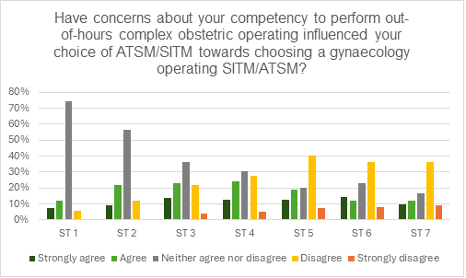
Figure 21: Have concerns about your competency to perform out-of-hours complex obstetric operating influenced your choice of ATSM/SITM towards choosing a gynaecology operating SITM/ATSM

If your future unit ensured out-of-hours support/mentorship for advanced operating, would you be less likely to choose a gynaecology operating SITM/ATSM?

About 60% of trainees across training years answered “No,” indicating that out-of-hours support would not change their decision to pursue gynaecology-focused SITM/ATSM pathways. However, 23% responded “Yes,” showing that a significant minority would feel less pressure to choose these pathways if additional mentorship was guaranteed. A further 12% selected N/A, reflecting either disinterest or that the question did not apply to their situation. These results highlight that while structural mentorship would help some trainees, systemic training limitations remain the stronger factor influencing career direction, pointing to poor visibility and uneven access despite capacity.
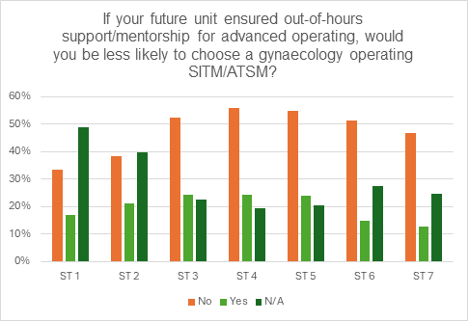
Figure 22: If your future unit ensured out-of-hours support/mentorship for advanced operating, would you be less likely to choose a gynaecology operating SITM/ATSM?

Clinics
Only around 40% of Stage 2 and Stage 3 trainees reported having adequate opportunities to attend gynaecology clinics appropriate for their learning stage (Figure 23). Stage 1 trainees appear most affected, with more than half reporting disagreement and fewer than one-third agreeing that they could attend clinics frequently enough.
These figures mirror the overall picture from last year, while opportunities increase slightly with seniority, significant gaps remain. One-quarter of advanced trainees and one-third of Stage 2 trainees still report insufficient opportunities to attend clinics regularly. Nationally, only one-third of all trainees agreed they had adequate clinic exposure, while more than half disagreed (Figure 24).

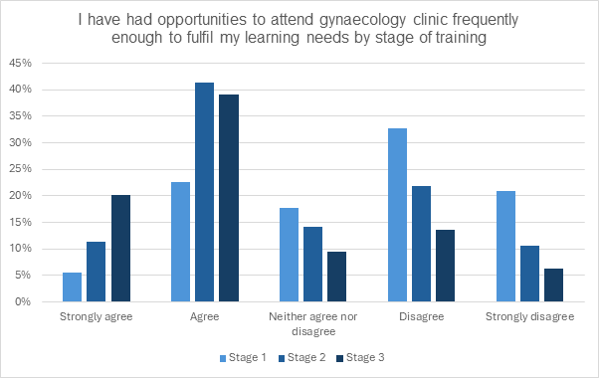
Figure 23: I have had opportunities to attend gynaecology clinic frequently enough to fulfil my learning needs by stage of training
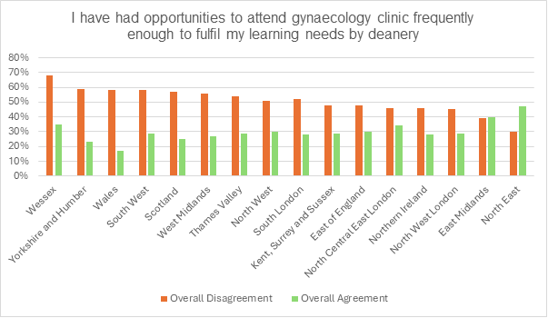
Figure 24: I have had opportunities to attend gynaecology clinic frequently enough to fulfil my learning needs by deanery

Access to specialist gynaecology clinics is even more limited than for general clinics (Figure 25, 26). A striking 63% of Stage 1 trainees and 54% of Stage 2 trainees reported inadequate opportunities to attend, while only 38% of Stage 3 trainees felt they had sufficient access. Nationally, the pattern mirrors that of general clinics, on average, just 30% of trainees reported adequate opportunities, while half disagreed.
The North East and East Midlands outperform the national average in access to both general and specialist gynaecology clinics, indicating that their models of delivery may offer valuable insights for improving clinic exposure elsewhere. The issue appears systemic, with most trainees across the UK reporting insufficient clinic exposure Exploring how high-performing regions overcome structural pressures, such as balancing service demands with educational needs, could help inform solutions to improve access nationwide.

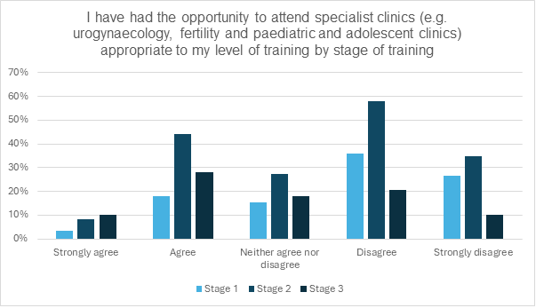
Figure 25: I have had the opportunity to attend specialist clinics (e.g. urogynaecology, fertility and paediatric and adolescent clinics) appropriate to my level of training by stage of training
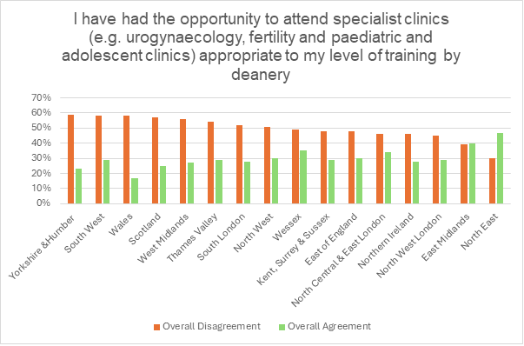
Figure 26: I have had the opportunity to attend specialist clinics (e.g. urogynaecology, fertility and paediatric and adolescent clinics) appropriate to my level of training by deanery

Supervision
Overall, trainee satisfaction with direct clinical supervision and their hospitals remains high, with majority reporting appropriate supervision in elective theatre, clinic and out of hours supervision (Figure 27) and feeling supported in completing workplace-based assessments (Figure 28). However, this positive local sentiment contrasts sharply with a significant decline in confidence regarding competency attainment among senior trainees. While 70% of junior trainees (ST1/2) feel on track, this figure falls to just 50% at the senior level (ST6/7) (Figure 29). This growing gap is likely driven by increased complexity of senior curriculum requirements and persistent, systemic barriers to accessing essential training in specialised theatre lists, clinics and ultrasound.

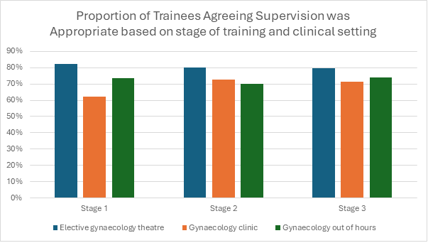
Figure 27: Proportion of Trainees Agreeing Supervision was Appropriate based on stage of training and clinical setting

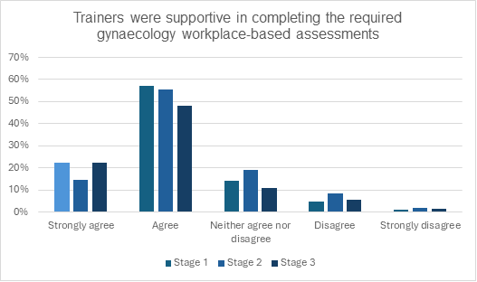
Figure 28: Trainers were supportive in completing the required gynaecology workplace-based assessments

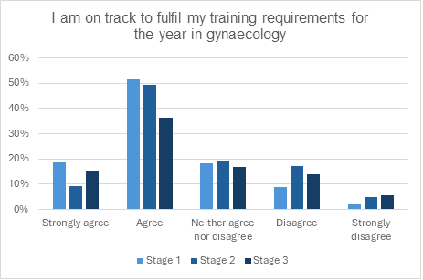
Figure 29: I am on track to fulfil my training requirements for the year in gynaecology

This pattern is not an isolated issue but reflects a consistent national trend (Figure 30, 31). The fact that regional data across the country shows similar levels of overall satisfaction alongside specific deficits in advanced training opportunities confirms that the challenge is structural rather than local. Therefore, while trainees generally feel supported by their immediate supervisors, their declining confidence in meeting competencies points to a broader, national level crisis in securing adequate advanced training capacity. Addressing this will require strategic interventions aimed at the root causes affecting the entire training system.

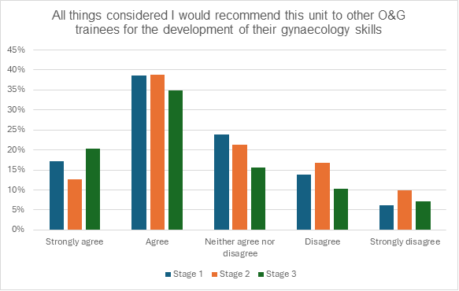
Figure 30: All things considered I would recommend this unit to other O&G trainees for the development of gynaecology skills by stage of training

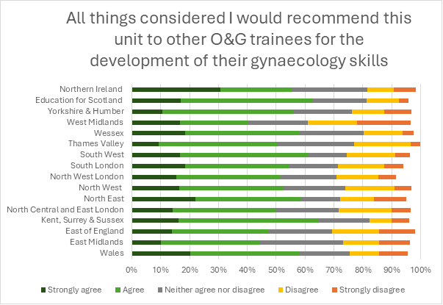
Figure 31: All things considered I would recommend this unit to other O+G trainees for the development of their gynaecology skills by deaneries

Ultrasound Training

Transabdominal Ultrasound in Early Pregnancy
A key concern is that transabdominal ultrasound (TAUSS) in early pregnancy is a mandatory requirement by ST3, yet access to training remains poor at all early stages. Figure 32 demonstrates among junior trainees, 66% of ST1s and 60% of ST2s reported that they disagree or strongly disagree with having received adequate training opportunities. Worryingly, even at ST3 — the point at which competency is expected — 54% of trainees still felt they lacked sufficient training. Although this proportion decreases in later years, a substantial minority persists, with 27% of ST7s continuing to report inadequate opportunities.
Unsurprisingly, this deficit is mirrored in assessment opportunities, with high levels of dissatisfaction among ST1–3 trainees (See Figure 33). While advanced trainees report more positive experiences, this may reflect retrospective opportunities gained later in training rather than a systematic, structured pathway. It may also be that seniority itself increases access to clinical cases and assessments, rather than equitable provision across all levels.
Perhaps most strikingly, even those who have been assessed as competent report ongoing challenges in maintaining their skills (Figure 34). Several intermediate trainees indicated that they lack adequate opportunities for continued practice, suggesting that the pipeline from training through assessment to sustained expertise is not functioning effectively.

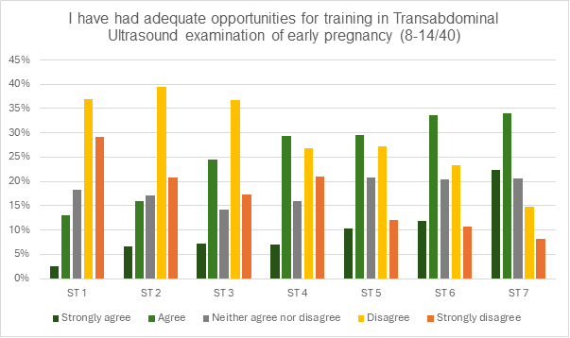
Figure 32: I have had adequate opportunities for training in Transabdominal Ultrasound examination of early pregnancy (8-14/40)
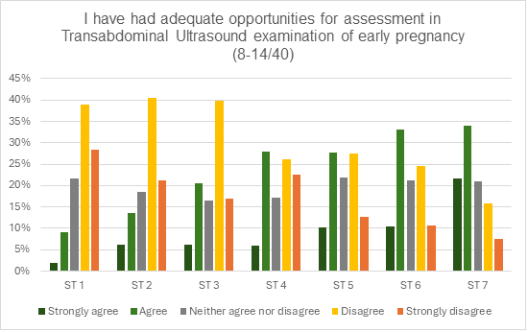
Figure 33: I have had adequate opportunities for assessment in Transabdominal Ultrasound examination of early pregnancy (8-14/40)

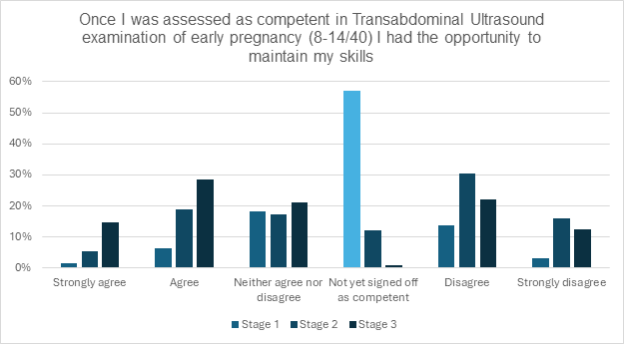
Figure 34: Once I was assessed as competent in Transabdominal Ultrasound examination of early pregnancy (8-14/40) I had the opportunity to maintain my skills

Transvaginal Ultrasound in Gynaecology

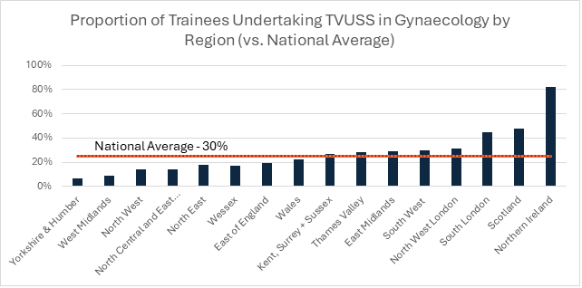
Figure 35: Proportion of Trainees Undertaking TVUSS in Gynaecology by Region (vs. National Average)

The national average of trainees undertaking transvaginal ultrasound (TVUSS) in gynaecology is currently 30%, which represents a modest increase from 22% in the previous year (Figure 35), 82% of trainees in Northern Ireland undertake ultrasound training, the highest proportion nationally. This is followed by Scotland (48%) and South London (45%), both of which are above the national average.
As shown in Figure 36, almost 60% of basic trainees in Northern Ireland are undertaking gynaecology ultrasound training, whereas in Scotland and South London, training is more commonly concentrated during the intermediate and advanced stages. This is despite Scotland and South London having the second- and third-highest overall rates of training nationally, suggesting that while uptake is relatively high in these regions, opportunities for earlier exposure remain limited compared to Northern Ireland.
There continues to be considerable variation in access to TVUSS training across the UK, with many regions falling well below the national benchmark. These findings suggest that access remains uneven, likely influenced by regional training structures and resources, with persistent disparities evident across England.

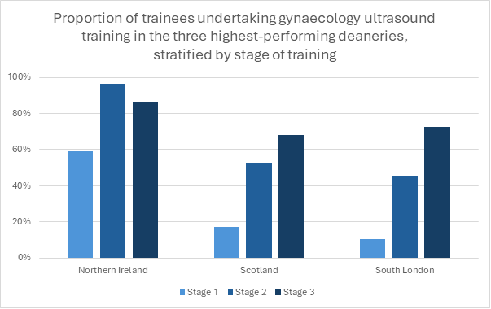
Figure 36: Proportion of trainees undertaking gynaecology ultrasound training in the three highest-performing deaneries, stratified by stage of training

Despite a national average of only 30% uptake in TVUSS training in gynaecology, perceptions of adequate opportunities remain relatively high, particularly among advanced trainees (Figure 37). This contrast suggests that while relatively few trainees are formally undertaking TVUSS training, those who do often feel they are receiving sufficient exposure. Advanced trainees were the most likely to report agreement, reflecting that training opportunities are typically concentrated later in training. However, a minority expressed dissatisfaction, with 14% disagreeing and 5% strongly disagreeing that they were receiving adequate opportunities.
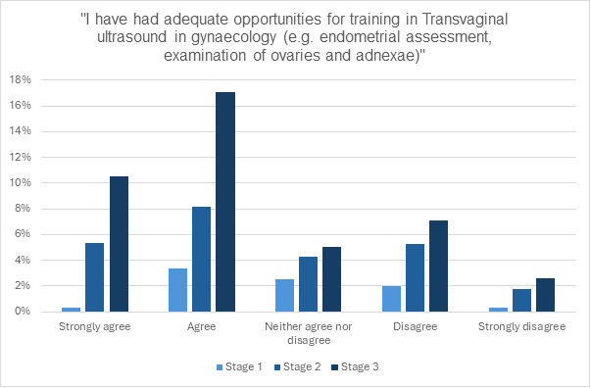
Figure 37: I have had adequate opportunities for training in Transvaginal ultrasound in gynaecology (e.g. endometrial assessment, examination of ovaries and adnexae)
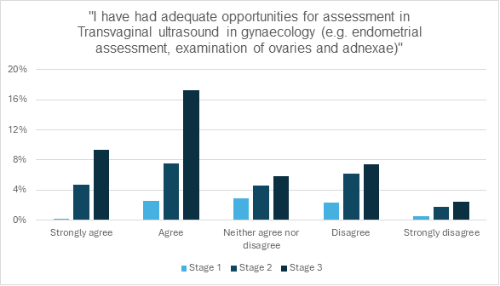
Figure 38: I have had adequate opportunities for assessment in Transvaginal ultrasound in gynaecology (e.g. endometrial assessment, examination of ovaries and adnexae)"

Figure 38 demonstrates a significant disconnect between training and assessment in transvaginal ultrasound skills. While a strong majority of trainees, particularly at advanced levels, agree they have had adequate opportunities for training, there is a consistent and notable deficit in formal assessment across all skill levels. This "assessment gap" is evident even among advanced trainees, suggesting a systemic failure to formally evaluate competency despite providing training.

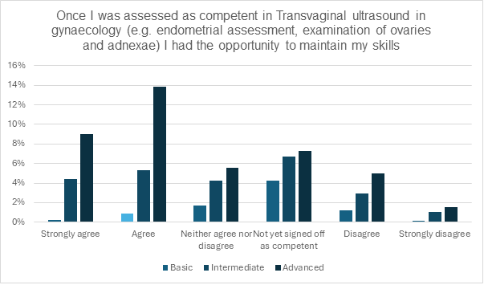
Figure 39: Once I was assessed as competent in Transvaginal ultrasound in gynaecology (e.g. endometrial assessment, examination of ovaries and adnexae) I had the opportunity to maintain my skills

Figure 39 reveals a concerning trend regarding skill maintenance in transvaginal ultrasound. It shows that a significant proportion of trainees across all skill levels (Basic, Intermediate, and Advanced) do not feel they have adequate opportunities to maintain their skills even after they have been assessed as competent. The presence of the "not yet signed off as competent" category confirms that the previous assessment gap is a barrier, preventing some from even reaching the point of considering skill maintenance. This suggests that achieving competency is not the final challenge; a lack of ongoing practice opportunities threatens the retention of these crucial diagnostic skills over time.

Transvaginal Ultrasound in Early Pregnancy

Only 22% of trainees are undertaking transvaginal ultrasound in early pregnancy. ⅓ of stage 3 trainees are undertaking transvaginal ultrasound in early pregnancy (Figure 40). Northern Ireland remains the only region where more trainees are undertaking TVUSS in early pregnancy than not at 65%. These figures remain consistent with last year suggesting that no significant improvements have been made.

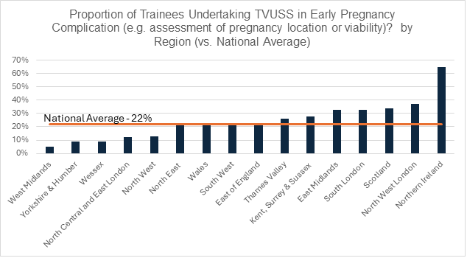
Figure 40: Proportion of Trainees Undertaking TVUSS in Early Pregnancy Complication (e.g. assessment of pregnancy location or viability)? by Region (vs. National Average)

Despite this uneven uptake, perceptions of training opportunities remain relatively positive, particularly among advanced trainees. As shown in Figures 41-43 most senior trainees agreed they had adequate opportunities for training in early pregnancy complications, while basic and intermediate trainees were less likely to do so. A smaller proportion expressed dissatisfaction, with approximately 14% disagreeing and 5% strongly disagreeing that they had sufficient opportunities. Once assessed as competent, most advanced trainees also reported being able to maintain their skills, although a notable proportion of trainees across all stages indicated that they had not yet been signed off as competent.
Taken together, these findings highlight a mismatch between training uptake and perceptions of adequacy. While the overall number of trainees accessing TVUSS training remains low and varies widely by region, those who do receive training generally report it as adequate and sustainable. However, opportunities for early exposure are limited, and persistent disparities in access suggest that training provision is strongly shaped by regional structures and stage of training.

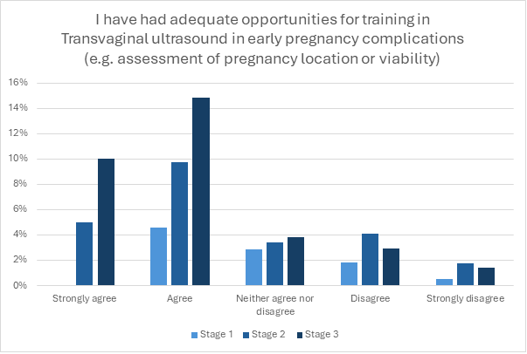
Figure 41: I have had adequate opportunities for training in Transvaginal ultrasound in early pregnancy complications (e.g. assessment of pregnancy location or viability)

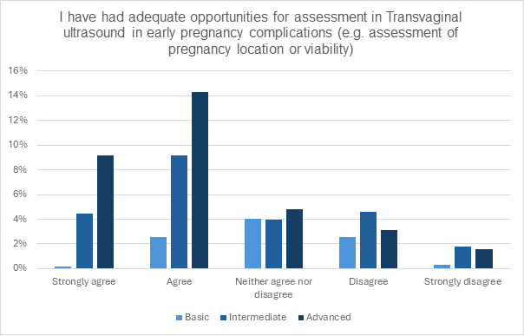
Figure 42: I have had adequate opportunities for assessment in Transvaginal ultrasound in early pregnancy complications (e.g. assessment of pregnancy location or viability)

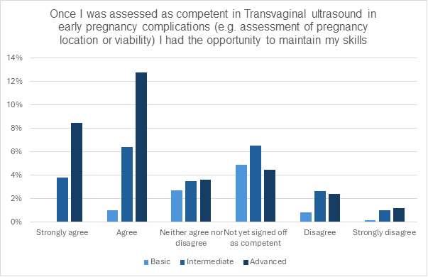
Figure 43: Once I was assessed as competent in Transvaginal ultrasound in early pregnancy complications (e.g. assessment of pregnancy location or viability) I had the opportunity to maintain my skills
Ultrasound Opportunities

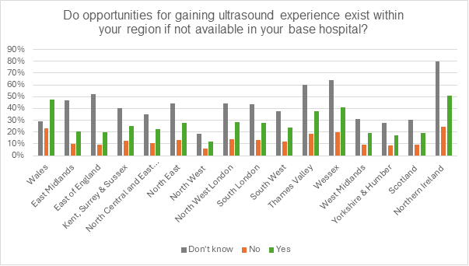
Figure 44: Do opportunities for gaining ultrasound experience exist within your region if not available in your base hospital? By deanery

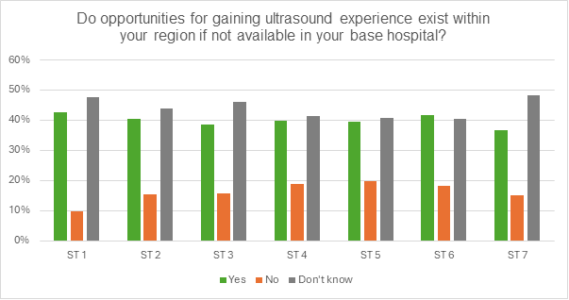
Figure 45: Do opportunities for gaining ultrasound experience exist within your region if not available in your base hospital? By stage of training

Looking at Figure 44, Northern Ireland stands out as a particularly interesting case. While 80% of trainees responded “Don’t know” to the question of opportunities outside their base hospital—the highest rate in the UK—this must be interpreted in context. In Northern Ireland, consultants are expected to scan rather than relying on sonographers, creating more direct opportunities for trainees. This reflects a highly effective hospital-based training model where most needs are met internally, meaning that a lack of awareness of external opportunities likely signals sufficiency rather than deficit.
By contrast, across most other deaneries, persistently high “Don’t know” responses point to systemic failures in communication and dissemination of information about regional training pathways. This pattern is consistent across training levels (Figure 45), underscoring the need for better visibility and coordination to ensure equitable access to ultrasound training nationwide.

Discussion
Looking back at last year’s report, it appears that training opportunities have not substantially changed, and it remains difficult to determine whether any observed improvements or declines are statistically significant. Early-stage trainees continue to face significant challenges in acquiring basic surgical skills. While exposure to intermediate procedures shows some improvement, access to advanced procedures remains inconsistent, and opportunities for robotic surgery training are still extremely limited and highly variable across regions.

The survey continues to highlight marked inconsistencies in the provision, access, and quality of training across deaneries—particularly in relation to simulation, ultrasound exposure, mentorship, and out-of-hours surgical support. Simulation training, a cornerstone of modern surgical education, is currently delivered through a fragmented and non-standardised model. Early-stage trainees often lack awareness or access to simulation opportunities, and limited high-fidelity resources coupled with inconsistent feedback reduce its overall educational value. Similarly, access to clinics and ultrasound training, both transabdominal and transvaginal, remains uneven, with many trainees uncertain about where to obtain these experiences.

Concerns regarding out-of-hours surgical competency do not appear to influence career choices. Trainees remain highly motivated, with strong agreement that all O&G trainees should achieve competency in advanced procedures by CCT, and many actively pursuing SITM or SST modules. However, as the landscape of gynaecological surgery continues to evolve, trainees are increasingly aware that achieving adequate surgical exposure within the current system may not be feasible. This represents a missed opportunity to harness trainee enthusiasm—one that could be mitigated by strengthening simulation-based training to address existing structural gaps.

For a well-rounded training experience, trainees require not only procedural exposure but also consistent access to clinics, ultrasound, and mentorship. With an increasing number of gynaecological procedures moving to office-based settings, access to clinics has become even more critical for acquiring practical skills and clinical decision-making experience. One potential strategy to enhance learning while addressing service pressures could involve better integrating trainees into clinic delivery, thereby supporting both education and service provision. The RCOG recommends a minimum of 12 gynaecology clinics per year; consideration should be given to making this a mandatory ARCP requirement to ensure equitable access and accountability across training programmes.

The ongoing RCOG Surgical Skills Project aims to address many of the issues identified in this report, with broad, high-level recommendations currently being developed. However, we are yet to see the impact of these recommendations in practice. As these objectives remain strategic in nature, it will take time for any tangible changes to filter through to local training environments and be reflected in trainee experience.

This year’s TEF responses once again highlight the persistent challenges within gynaecology training across the UK. Continued collaboration between training bodies, deaneries, hospitals, and industry partners will be essential to translate national initiatives into meaningful improvements on the ground. Supporting equitable access, robust supervision, and structured skills development will help ensure that today’s trainees are well prepared to become the consultants of tomorrow, maintaining high standards of safe and effective gynaecological care.

Recommendations
Enhance Access to Clinics
- Ensure trainees have equitable and consistent access to both general and specialist gynaecology clinics, providing a broad base of exposure across training levels.
- Consider making attendance at a minimum of 12 gynaecology clinics per year a formal ARCP requirement, in line with RCOG guidance, to ensure accountability and standardisation.
- Deaneries should outline available clinics at each hospital and set attendance expectations, using personalised schedules to ensure continuity with supervisors, consistent mentorship, and skills development.
Strengthen and Standardise Simulation Training
- Develop a shared, centralised tool or database (potentially hosted or endorsed by the RCOG) to map existing simulation training opportunities nationally, allowing trainees to easily identify and access available sessions across nearby hospitals or deaneries.
- Encourage collaboration between units and neighbouring deaneries to share simulation facilities, expertise, and funding, reducing inequities in access.
- Continue and expand national high-level simulation courses, such as the RCOG-led Open Hysterectomy Course, to provide consistent, high-quality training in core surgical procedures.
- Ensure simulation sessions include structured feedback and supervision to maximise educational value, and consider embedding simulation formally within the curriculum as a complement to operative experience.
Ultrasound Training and On-Call Opportunities
- Incorporate key emergency ultrasound skills into the curriculum to ensure trainees gain adequate exposure and practical experience in acute gynaecological presentations (e.g., miscarriage, ectopic pregnancy).
- Explore point-of-care ultrasound (POCUS) training during on-call shifts to reinforce learning, improve confidence, and enhance patient safety.
- Provide access to structured ultrasound training courses (national or regional), ensuring trainees can receive formal, supervised hands-on experience.
- Collaborate with the Royal College of Radiologists (RCR) to develop standardised approaches that guarantee O&G trainees receive high-quality ultrasound training across all deaneries.
- Integrate ultrasound training into routine clinical workflow where feasible, supporting both educational outcomes and efficient patient care

Questions

Gynaecology Training
I have had sufficient opportunities to develop or maintain my gynaecological surgical skills appropriate to my level of training in: (5.2.1.1 / 5.2.2.1 / 5.2.3.1)
5.2.1.2 / 5.2.2.2 /5.2.3.2 | Emergency procedures (SMM, I+D)
5.2.1.3 / 5.2.2.3 /5.2.3.3 | Emergency procedures e.g. SMM, emergency diagnostic laparoscopy
5.2.1.4 / 5.2.2.4 /5.2.3.4 | Basic procedures e.g. SMM, I+D Bartholin's
5.2.1.6 / 5.2.2.6 /5.2.3.6 | Intermediate procedures e.g. diagnostic laparoscopies, hysteroscopy, simple operative laparoscopy
5.2.1.7 / 5.2.2.7 /5.2.3.7 | Robotic surgery
5.2.1.7.1 / 5.2.2.7.1 /5.2.3.7.1 | Having a robot in my unit is adversely affecting my theatre time or surgical skills training
5.2.1.8 5.2.2.8 /5.2.3.8 | Advanced procedures e.g. operative laparoscopy, open gynaecological surgery, gynae oncology surgery, surgical management ectopic pregnancy

5.3.1 | How is simulation training provided in your region?
5.3.2 | What simulation equipment is available for use in your unit?
5.3.3 | I am given time to attend simulation training
5.3.4 | I have easy access to simulation equipment
5.3.5 | I have access to feedback during simulation training
5.3.6 | I feel that on completion of training, all O&G trainees should be competent to perform advanced gynaecological procedures e.g. hysterectomy/myomectomy
5.3.7 | I feel that it is realistic to train all O&G trainees to be competent in advanced gynaecology operating e.g. hysterectomy/myomectomy within the current system
5.3.8 | I am/plan to undertake a SITM/SST that would enable me to be competent to perform advanced gynaecological procedures on completion of training
5.3.9 | Have concerns about your competency to perform out-of-hours complex gynaecological operating influenced your choice of ATSM/SITM towards choosing a gynaecology operating SITM/ATSM?
5.3.10 | Have concerns about your competency to perform out-of-hours complex obstetric operating influenced your choice of ATSM/SITM towards choosing a gynaecology operating SITM/ATSM?
5.3.11 | If your future unit ensured out-of-hours support/mentorship for advanced operating, would you be less likely to choose a gynaecology operating SITM/ATSM?

5.4.1 | I have had opportunities to attend gynaecology clinic frequently enough to fulfil my learning needs
5.4.2 | I have had the opportunity to attend specialist clinics (e.g. urogynaecology, fertility and paediatric and adolescent clinics) appropriate to my level of training
5.5.1 | I have had appropriate supervision for my level of training in elective gynaecology theatre
5.5.2 | I have had appropriate supervision for my level of training in gynaecology clinic
5.5.3 | I have had appropriate supervision for my level of training in gynaecology outside of normal hours
5.5.4 | Trainers were supportive in completing the required gynaecology workplace-based assessments
5.5.5 | My clinical supervisors have provided me with feedback that is constructive and helpful
5.6 | I am on track to fulfil my training requirements for the year in gynaecology
5.7 | All things considered I would recommend this unit to other O&G trainees for the development of their gynaecology skills

Ultrasound Training
7.1.1 | I have had adequate opportunities for training in Transabdominal Ultrasound examination of early pregnancy (8-14/40)
7.1.2 | I have had adequate opportunities for assessment in Transabdominal Ultrasound examination of early pregnancy (8-14/40)
7.1.3 | Once I was assessed as competent in Transabdominal Ultrasound examination of early pregnancy (8-14/40) I had the opportunity to maintain my skills
7.6 | Are you undertaking Transvaginal ultrasound in gynaecology (e.g. endometrial assessment, examination of ovaries and adnexae)?
7.6.1 | I have had adequate opportunities for training in Transvaginal ultrasound in gynaecology (e.g. endometrial assessment, examination of ovaries and adnexae)
7.6.2 | I have had adequate opportunities for training in Transvaginal ultrasound in gynaecology (e.g. endometrial assessment, examination of ovaries and adnexae)
7.6.3 | Once I was assessed as competent in Transvaginal ultrasound in gynaecology (e.g. endometrial assessment, examination of ovaries and adnexae) I had the opportunity to maintain my skills
7.7 | Are you undertaking Transvaginal ultrasound in early pregnancy complications (e.g. assessment of pregnancy location or viability)?
7.7.1 | I have had adequate opportunities for training in Transvaginal ultrasound in early pregnancy complications (e.g. assessment of pregnancy location or viability)
7.7.2 | I have had adequate opportunities for assessment in Transvaginal ultrasound in early pregnancy complications (e.g. assessment of pregnancy location or viability)
7.7.3 | Once I was assessed as competent in Transvaginal ultrasound in early pregnancy complications (e.g. assessment of pregnancy location or viability) I had the opportunity to maintain my skills
7.8 | Do opportunities for gaining ultrasound experience exist within your region if not available in your base hospital?


Find out more at

